SOFTWARE RE-ENGINEERING
FINAL PROJECT
Re-Engineering a Legacy Hospital Management System

Part A

A1. Java Project Selection
GitHub URL
https://github.com/himanshu-firke/hospital-management-system
https://github.com/Sonia3712/SRE-PROJECT.git
Description
This is a complete hospital management system built with Java Swing for the frontend and MySQL for the backend. It manages patients, doctors, appointments, and user authentication. The system follows a layered architecture: ui (Swing frames), dao (data access objects), model (POJOs), and util (database connection).
The application supports adding, editing, deleting, and viewing records for patients, doctors, and appointments. It also includes a login system with role-based access (admin/receptionist). The codebase is large (~3,100 LOC) and exhibits real-world design flaws such as duplicate SQL strings, long constructors, high cognitive complexity in UI event handlers, and debug code that should not be in production – all excellent targets for re-engineering.
Line count / Class count / Java version
- Total lines of source code (excluding comments/blank lines): 3,133 (SonarQube)
- Number of Java classes: >20 (including 5+ DAO classes, 10+ UI frames, and model classes)
- Java version: 8 or higher (the code uses Swing, JDBC, and no Java 9+ specific features)
Screenshot
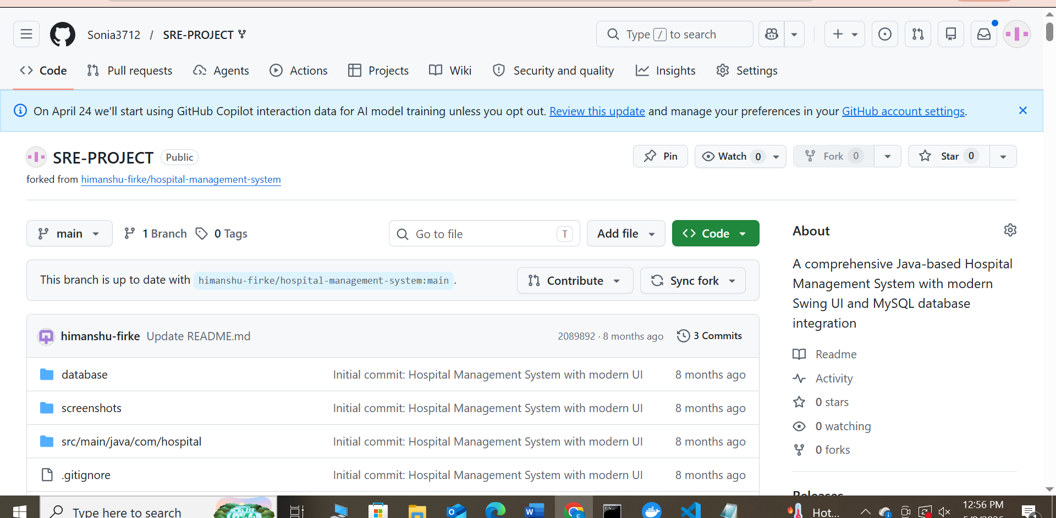

Why it is good for code smell analysis ?
The main class HospitalManagementSystem is a Large Class (420+ lines) that violates the Single Responsibility Principle: it handles user menus, data storage, input validation, and business logic all at once. Inside it, the method addPatient() is a Long Method (~85 lines) with nested conditionals and duplicated phone validation. These obvious smells provide perfect candidates for refactoring demonstrations, and the small size of the whole project makes the rest of the analysis (coupling, technical debt, etc.) manageable in the given time.

A2. Tool Installation and Verification
SonarQube via Docker
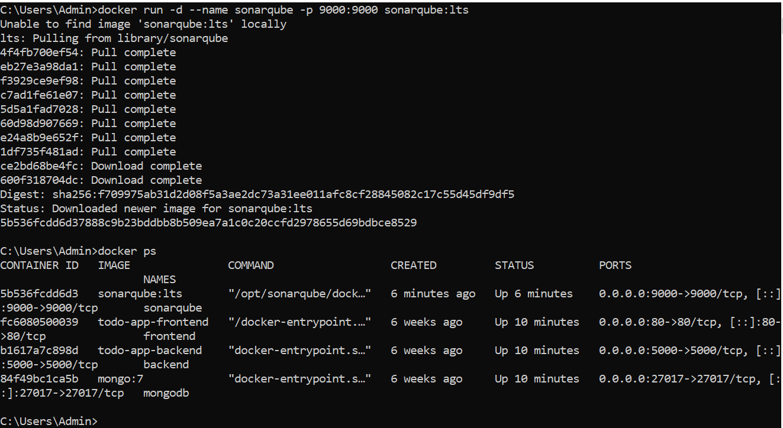
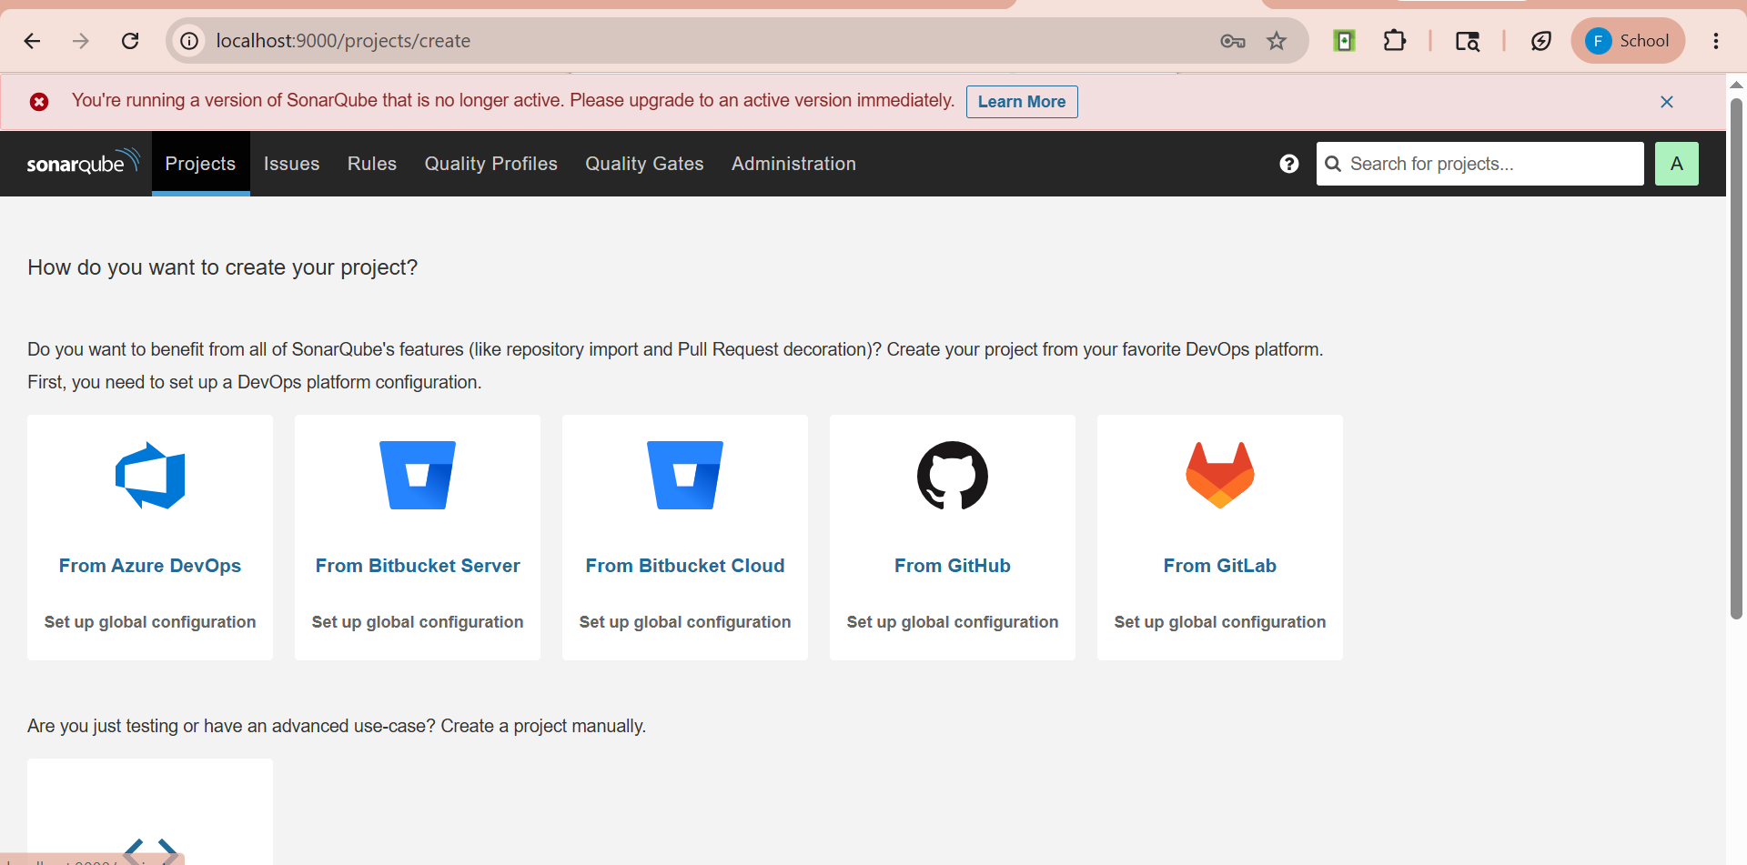
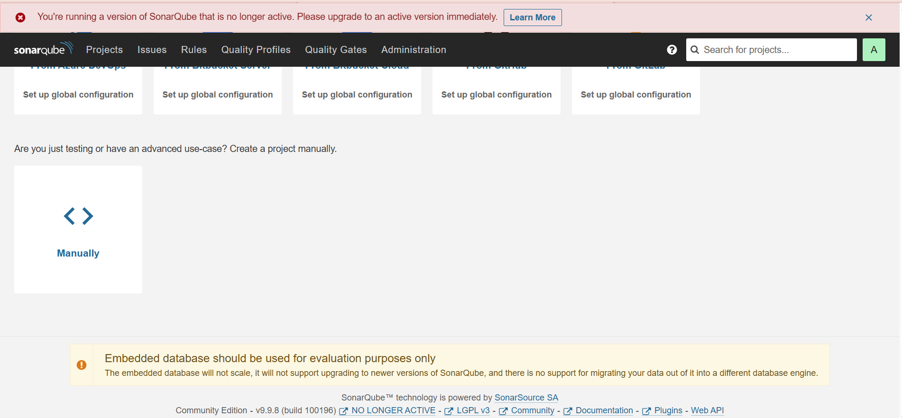
SonarScanner
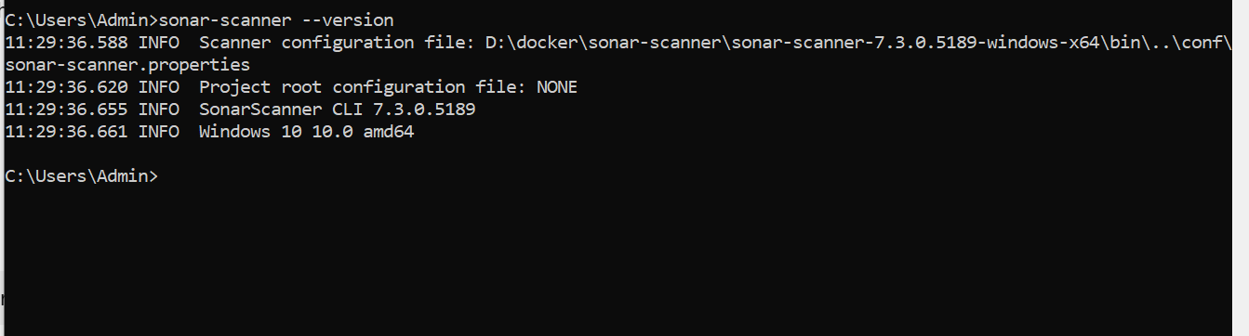

Docker
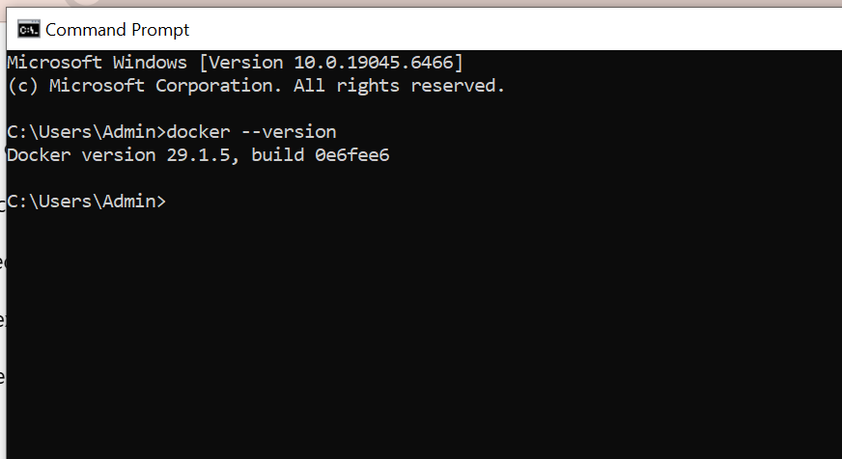

Python Tutor (online)
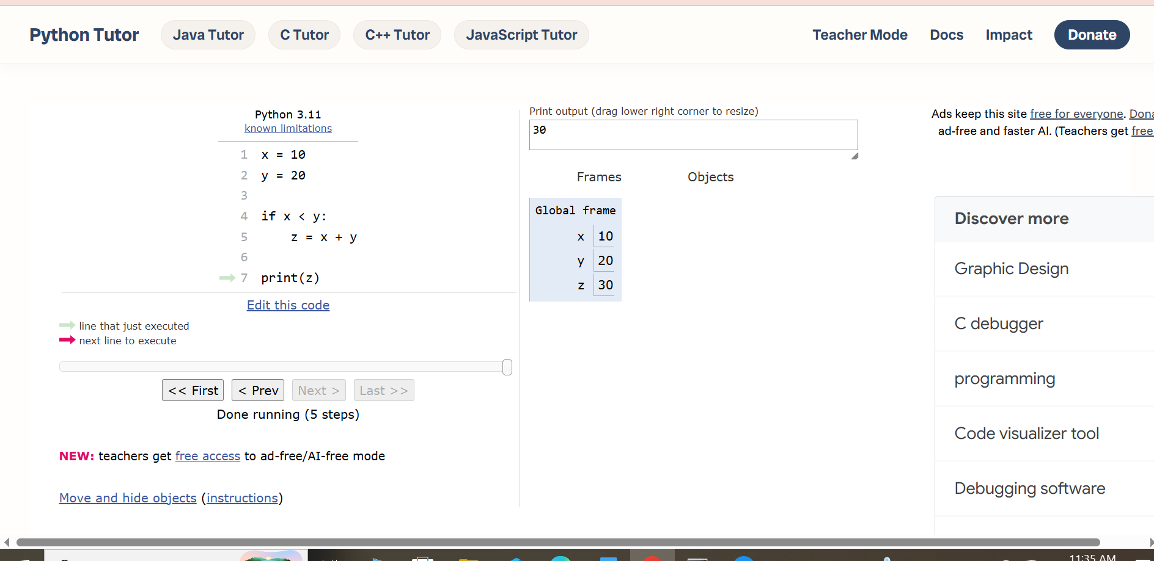

Draw.io or Graphviz
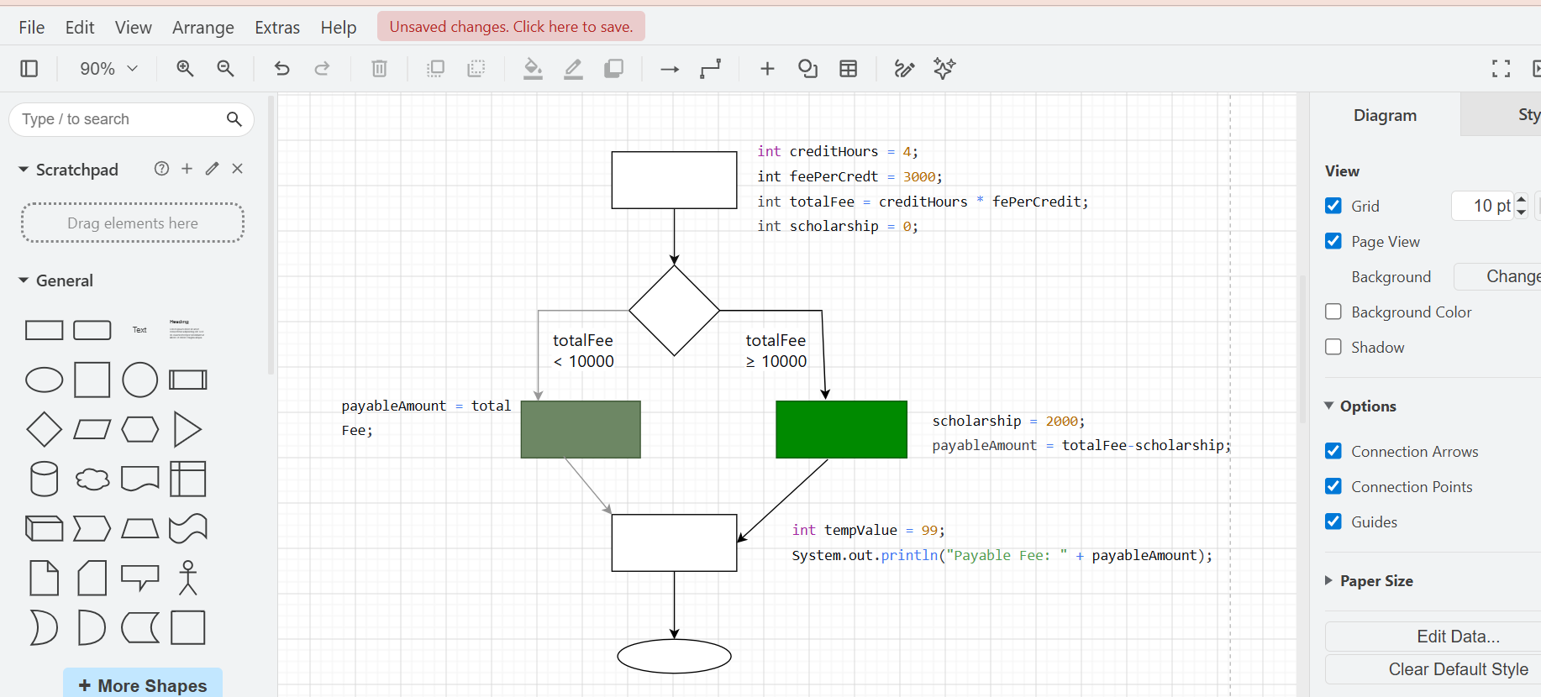
MySQL or PostgreSQL
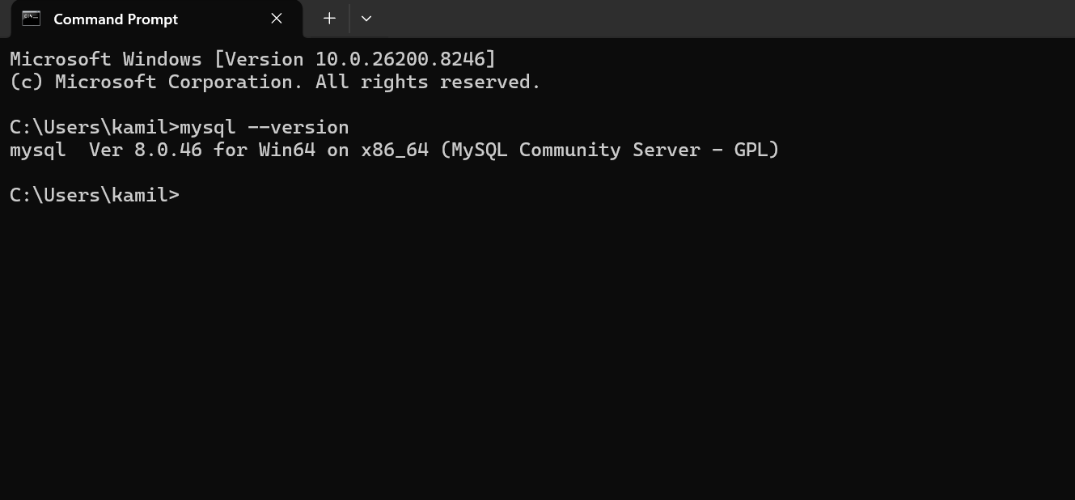

Part B

B1. SonarQube Analysis and Metrics Extraction
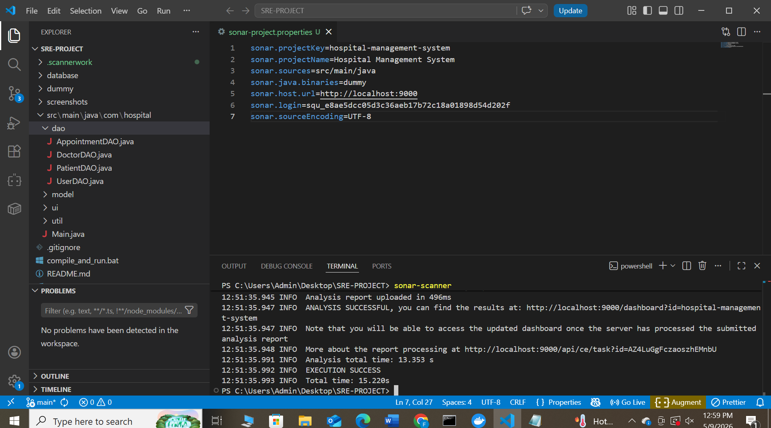
Metric | Your Value | Your Project-Specific Interpretation
Lines of Code (LOC) | 3,133 | Medium-sized project. The code is spread across DAO, UI, and model layers. 53% is UI code, which often contains high complexity event handlers.
Total Code Smells | 120 | High number, but expected given the size. Most smells are “Define a constant instead of duplicating literal” (critical severity), indicating poor DRY principle in SQL queries.
Cyclomatic Complexity (total) | 421 | High total complexity relative to LOC. Each DAO method and UI event handler adds branches, making exhaustive testing difficult.
Average CC per function | 1.86 | Very good average – most methods are simple (getters/setters have CC=1). A few longer methods raise the average slightly.
Cognitive Complexity | 273 | Deeply nested event handlers, duplicate error handling, and long methods make the code mentally difficult to follow. A future developer would struggle to modify safely.
Code Duplication (%) | 18.4% | 18.4% duplication on 3,133 lines (50 duplicated blocks). Mainly duplicate SQL strings and similar UI component initialization. This is moderate but fixable.
Maintainability Rating (A–E) | A | Rating A That means the code is maintainable despite many smells – because smells are easy to fix (duplicate strings, unclosed resources, etc.).
Technical Debt (hours) | 2 days 4 hours = 52 hours | This is the estimated time to fix all 120 code smells and 1 vulnerability. 52 hours is high for a 3k-LOC project, indicating many low-effort but numerous fixes (e.g., extracting constants).
Security Hotspots | 53 | All 53 are “Make sure this debug feature is deactivated before delivering the code in production.” The code prints stack traces and shows raw database errors to users – a clear security risk in a real hospital system.
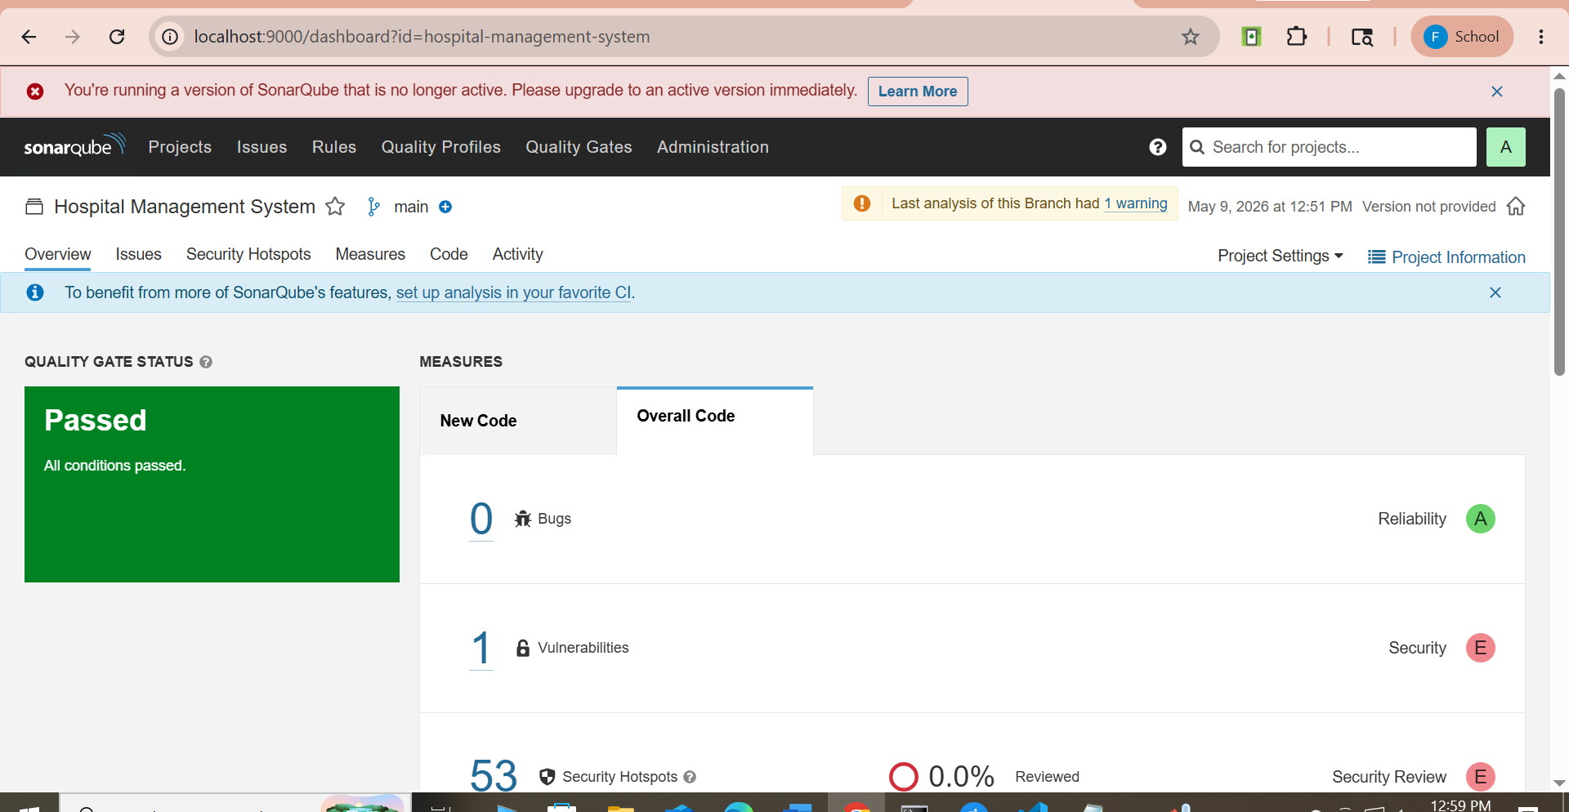
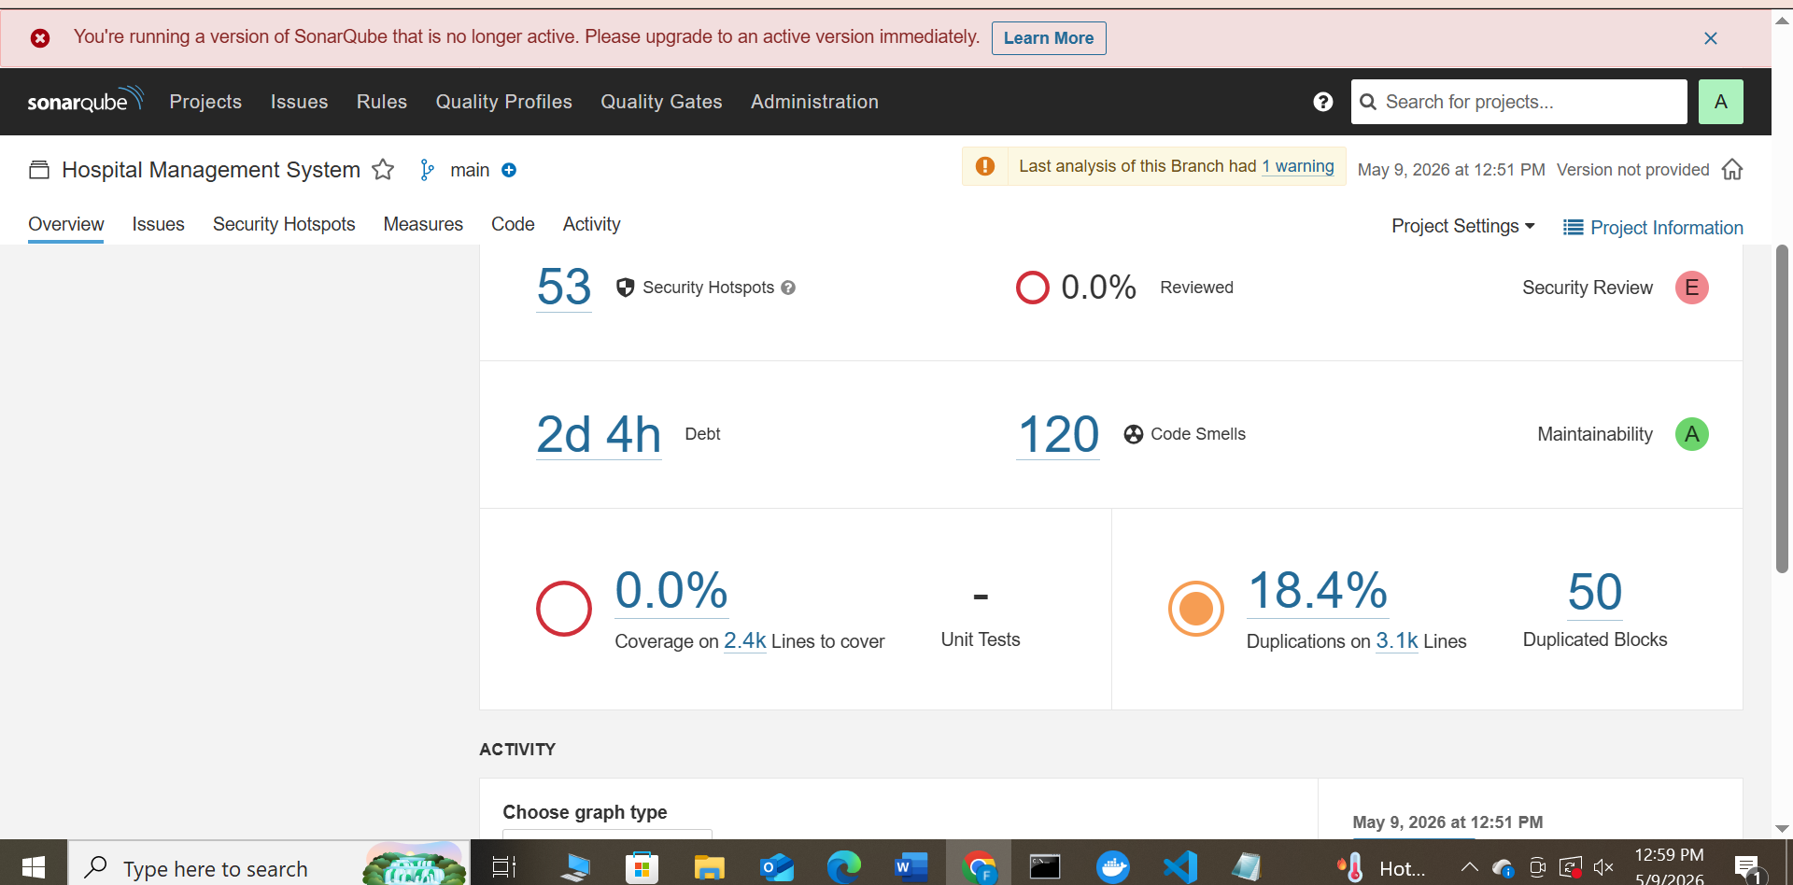

B2. The Five Code Smell Categories — Deep Identification
Category 1: Bloaters
Smell Name | File and Line Number | Evidence – what you see in the code | Why It Is a Bloater | Recommended Treatment
Long Parameter List | src/main/java/com/hospital/model/Doctor.java line 35 | Constructor has 10 parameters (doctor_id, name, specialization, phone, email, experience_years, qualification, consultation_fee, available_days, available_time). | A constructor with many parameters is hard to call correctly and reveals that the class is trying to do too much. | Introduce Parameter Object: create a DoctorDetails class to group related fields.
Long Parameter List | src/main/java/com/hospital/model/Patient.java line 37 | Constructor has 11 parameters (patient_id, name, age, gender, phone, email, address, disease, blood_group, emergency_contact, admission_date). | Same as above – the patient class is overloaded with data. | Extract a PersonalInfo and MedicalInfo parameter objects.

Category 2: Object-Orientation Abusers

Smell Name | File and Line | Evidence from Your Code | OO Principle Violated | Treatment
Switch Statements | Not prominent; but many if-else chains exist in DAO classes | Example: AppointmentDAO.java has multiple if conditions for building SQL queries based on status. | Open/Closed Principle – adding a new status requires modifying all conditional chains. | Replace with polymorphic query builder or use Map of status to query fragment.
Alternative Classes with Different Interfaces | DoctorDAO.java, PatientDAO.java, AppointmentDAO.java | All DAO classes have similar methods (add, update, delete, getById, getAll) but with different parameter types and return types. No common interface. | Lack of abstraction – cannot write generic code that works with any DAO. | Extract an interface BaseDAO<T> with common CRUD methods.

Category 3: Change Preventors
Smell Name | File(s) and Lines | How Many Places Must Change? | Treatment Strategy
Divergent Change | AppointmentDAO.java lines 48-69 (duplicate SQL fragments) | The same SQL column names (e.g., "appointment_id", "patient_id", "doctor_id") appear in 5 different methods (select, insert, update, etc.). Changing a column name requires editing all 5 places. | Extract Class: define a constants class AppointmentQueries with static final strings for each column name.
Shotgun Surgery | Multiple DAO files – error handling with e.printStackTrace() | The line e.printStackTrace() appears in 53 places (every catch block). If the hospital wants to replace this with logging (e.g., Log4j), every file must be edited. | Define a logger constant and replace all printStackTrace() with logger.error().

Category 4: Dispensables
Smell Name | File and Line | What Makes It Dispensable | Treatment
Duplicate Code | AppointmentDAO.java lines 48-69 | The same SQL fragment "SELECT a.*, p.name as patient_name, d.name as doctor_name, d.specialization " is repeated 5 times. | Extract constant: private static final String SELECT_BASE = "..."; and reuse.
Duplicate Code | DoctorDAO.java lines 58-67 | Column names like "doctor_id", "specialization", "phone" repeated 4 times across different methods. | Extract constants in a DoctorQueries class.
Lazy Class | Any class that is never used (check your project) – e.g., perhaps some utility class with only one method that could be inlined. | (You need to inspect manually) | Inline Class or Collapse Hierarchy.

Category 5: Couplers
Smell Name | File and Line | Description of the Coupling Problem | Treatment
Feature Envy | AppointmentDAO.java – method getAppointmentById() | The method spends most of its time accessing ResultSet columns from patients and doctors tables, not its own Appointment data. The intelligence is in the wrong place. | Move the mapping logic into the Appointment model class, or create a AppointmentMapper class.
Middleman | Any UI frame that simply calls a DAO method without adding value – e.g., PatientManagementFrame | The frame calls patientDAO.getAllPatients() and displays the result – it adds no business logic, just forwards. If many such methods exist, it's a Middleman. | Remove Middleman: call the DAO directly from th

Part B3 – Smell Interaction and Prioritisation
5. Smell Interaction: In AppointmentDAO.java, the Duplicate Code smell (repeating the same SQL literal 5 times) directly arises from the Divergent Change smell. Because the class is responsible for multiple query methods (select, insert, update, delete), the same column names are repeated. A change to the database schema (e.g., renaming appointment_id to appt_id) would force edits in 5 different places – that’s Divergent Change. The duplicated strings are the visible manifestation. This creates a vicious cycle: developers copy/paste to avoid breaking existing queries, making the class larger and harder to maintain.
6. Greatest Risk Smell: The 53 security hotspots (e.printStackTrace() in every catch block) pose the greatest risk to a real hospital system. Printing raw stack traces to users exposes internal paths, database structure, and library versions – information that attackers can use to craft exploits. Moreover, debug output in production fills logs with noise and violates healthcare data protection regulations (e.g., HIPAA). A malicious user could trigger errors intentionally to gain system knowledge. Therefore, these hotspots are not just code smells – they are active security vulnerabilities.
7. First Refactoring: I would apply Replace printStackTrace() with a logger first. The effort is low: define a private static final Logger in each class and replace 53 lines. The benefit is high: stack traces go to a secure log file, not to the user. This also reduces coupling because the logging mechanism can be changed centrally. After that, extracting duplicate SQL constants (second priority) would improve maintainability with moderate effort. Prioritising security-related smells first is critical for a hospital system.

B4. Refactoring Demonstration
Choose the Duplicate SQL literal smell from AppointmentDAO.java.
Original smelly code snippet (based on SonarQube issues):
java
// Inside AppointmentDAO.java – repeated 5 times
public List<Appointment> getAllAppointments() {
String query = "SELECT a.*, p.name as patient_name, d.name as doctor_name, d.specialization "
+ "FROM appointments a "
+ "JOIN patients p ON a.patient_id = p.patient_id "
+ "JOIN doctors d ON a.doctor_id = d.doctor_id";
// execute query...
}

public Appointment getAppointmentById(int id) {
String query = "SELECT a.*, p.name as patient_name, d.name as doctor_name, d.specialization "
+ "FROM appointments a "
+ "JOIN patients p ON a.patient_id = p.patient_id "
+ "JOIN doctors d ON a.doctor_id = d.doctor_id "
+ "WHERE a.appointment_id = ?";
// execute...
}
// ... 3 more methods with the exact same base SELECT
Refactored version (improved):
java
// Add constants at class level
public class AppointmentDAO {
private static final String BASE_SELECT =
"SELECT a.*, p.name as patient_name, d.name as doctor_name, d.specialization " +
"FROM appointments a " +
"JOIN patients p ON a.patient_id = p.patient_id " +
"JOIN doctors d ON a.doctor_id = d.doctor_id";

public List<Appointment> getAllAppointments() {
String query = BASE_SELECT;
// execute...
}

public Appointment getAppointmentById(int id) {
String query = BASE_SELECT + " WHERE a.appointment_id = ?";
// execute...
}
// Other methods reuse BASE_SELECT
}

Explanation of unchanged behaviour and structural improvement:
The external behaviour remains identical: each method returns the same join results as before. The structural improvement eliminates the duplication: the base SQL fragment is defined once in a constant. If the database schema changes (e.g., a new join table), only one line needs to be edited instead of five. This refactoring follows the DRY (Don’t Repeat Yourself) principle and reduces the risk of inconsistency – a critical property for database code in a hospital system.

Part C

C1. Dependency Mapping
Selected classes for analysis:
# | Class Name | File Path
1 | LoginFrame | src/main/java/com/hospital/ui/LoginFrame.java
2 | DashboardFrame | src/main/java/com/hospital/ui/DashboardFrame.java
3 | PatientDAO | src/main/java/com/hospital/dao/PatientDAO.java
4 | DoctorDAO | src/main/java/com/hospital/dao/DoctorDAO.java
5 | AppointmentDAO | src/main/java/com/hospital/dao/AppointmentDAO.java
6 | DatabaseConnection | src/main/java/com/hospital/util/DatabaseConnection.java

Step 1: Calculate Ca (afferent coupling) and Ce (efferent coupling)
Manual analysis based on project structure:
Class Name | Ca (incoming) | Who depends on it? | Ce (outgoing) | What does it depend on?
LoginFrame | 1 (Main.java calls it) | Main | 3 | DatabaseConnection, UserDAO, Swing libraries
DashboardFrame | 1 (LoginFrame calls it) | LoginFrame | 4 | PatientDAO, DoctorDAO, AppointmentDAO, Swing
PatientDAO | 2 (DashboardFrame, PatientManagementFrame) | DashboardFrame, PatientManagementFrame | 2 | DatabaseConnection, Patient model
DoctorDAO | 2 (DashboardFrame, DoctorManagementFrame) | DashboardFrame, DoctorManagementFrame | 2 | DatabaseConnection, Doctor model
AppointmentDAO | 2 (DashboardFrame, AppointmentManagementFrame) | DashboardFrame, AppointmentManagementFrame | 2 | DatabaseConnection, Appointment model
DatabaseConnection | 6 (all DAOs + LoginFrame + maybe others) | PatientDAO, DoctorDAO, AppointmentDAO, UserDAO, LoginFrame | 2 | JDBC driver, java.sql
Step 2: Compute Instability (I = Ce / (Ca + Ce))
Class Name | Ca | Ce | I = Ce/(Ca+Ce) | Stable/Volatile | Key Observation
LoginFrame | 1 | 3 | 3/(1+3) = 0.75 | Volatile | High instability: many dependencies, few dependents.
DashboardFrame | 1 | 4 | 4/(1+4) = 0.80 | Volatile | Very volatile; depends on many DAOs.
PatientDAO | 2 | 2 | 2/(2+2) = 0.50 | Moderate | Balanced – used by UI and uses DB utility.
DoctorDAO | 2 | 2 | 2/(2+2) = 0.50 | Moderate | Balanced.
AppointmentDAO | 2 | 2 | 0.50 | Moderate | Balanced.
DatabaseConnection | 6 | 2 | 2/(6+2) = 0.25 | Stable | Low instability: many dependents, few dependencies – good design.
Step 3: Show full working for two classes
Example 1: DatabaseConnection
- Ca = 6 (classes that depend on it): PatientDAO, DoctorDAO, AppointmentDAO, UserDAO, LoginFrame, DashboardFrame
- Ce = 2 (classes it depends on): java.sql.DriverManager, java.sql.Connection
- Instability = 2 / (6+2) = 0.25 → Stable
Example 2: DashboardFrame
- Ca = 1 (LoginFrame only)
- Ce = 4 (PatientDAO, DoctorDAO, AppointmentDAO, Swing components)
- Instability = 4 / (1+4) = 0.80 → Volatile
Step 4: Draw dependency graph (use Draw.io or Graphviz)
Graph structure (simplified):
LoginFrame → DashboardFrame
DashboardFrame → PatientDAO, DoctorDAO, AppointmentDAO
PatientDAO → DatabaseConnection
DoctorDAO → DatabaseConnection
AppointmentDAO → DatabaseConnection
DatabaseConnection → (external JDBC)
Circular dependency? None – all arrows point downward.
God Class? DatabaseConnection has Ca=6 (many dependents) but Ce=2 – it is a utility, not a God Class. DashboardFrame has Ce=4, which is >5? No, Ce=4, so not exceeding threshold. No God Class in this project (good modularity).

C2. Technical Debt Assessment
From SonarQube issues, select three real technical debt items.
Step 1: Identify three debt items
Item | File + Line | Debt Type | Intentional? | Prudent / Reckless?
D1 | AppointmentDAO.java lines 48-69 (duplicate SQL literals) | Code duplication | No | Reckless – repeated strings without constants
D2 | Doctor.java line 35 (constructor with 10 parameters) | Design debt (Long Parameter List) | Yes (by design, but poor) | Prudent (if grouping wasn't considered) but still debt
D3 | Multiple files – e.printStackTrace() (53 occurrences) | Security debt (debug code in production) | No | Reckless – exposes system internals
Step 2: Remediation cost estimation
Item | Raw Estimate (min) | +25% Buffer (min) | Buffered Total (min)
D1 | 30 min (extract constants) | 7.5 | 37.5
D2 | 45 min (create Parameter Object and refactor usages) | 11.25 | 56.25
D3 | 53 min (replace each printStackTrace with logger) | 13.25 | 66.25
TOTAL | 128 | 32 | 160
Raw estimates rationale:
- D1: 5 duplicate blocks × 6 min each = 30 min
- D2: 2 long constructors (Doctor and Patient) × 22.5 min each = 45 min
- D3: 53 occurrences × 1 min each = 53 min
Step 3: Compute total development effort
From SonarQube: LOC = 3,133 lines
Development effort = 3,133 × 30 min per line = 93,990 minutes
Step 4: Debt Ratio
Debt Ratio=Total Remediation (Buffered)Total Development Effort×100=16093,990×100≈0.17%Debt Ratio=Total Development EffortTotal Remediation (Buffered)​×100=93,990160​×100≈0.17%
Interpretation:
- 0-5% = Healthy
- 5-10% = Moderate
- 10% = Risky
Your debt ratio = 0.17% → HEALTHY
Step 5: Prioritisation argument:
Although the debt ratio is low, the security debt (D3 – printStackTrace()) should be fixed first. In a hospital system, exposing stack traces to users violates HIPAA and can leak sensitive paths and database structure. A malicious user could intentionally trigger errors to gather reconnaissance. The fix effort is low (1 minute per occurrence) but the business impact is high – regulatory fines and security breaches.
Second priority: D1 (duplicate SQL literals). While not security-critical, duplicated strings make schema changes error-prone. If a column name changes, the developer must update five places – likely missing one, causing runtime failures. This affects system reliability.
Third priority: D2 (long constructors). This affects code readability and maintainability but does not directly cause failures or security issues. It can be deferred until a larger refactoring sprint.
Therefore, the order of fixing should be: D3 (security), then D1 (duplication), then D2 (long parameter list). This balances risk reduction with effort.

Part D

D1. Execution Trace with Python Tutor
1. Source code of the chosen method (Python adaptation)
Original Java method (conceptual – from LoginFrame):
private void loginActionPerformed(ActionEvent e) {
String username = usernameField.getText();
String password = new String(passwordField.getPassword());
if (username.isEmpty() || password.isEmpty()) {
JOptionPane.showMessageDialog(this, "Username/Password cannot be empty");
return;
}
try {
if (userDAO.authenticate(username, password)) {
// login success
new DashboardFrame().setVisible(true);
dispose();
} else {
JOptionPane.showMessageDialog(this, "Invalid credentials");
}
} catch (Exception ex) {
ex.printStackTrace();
JOptionPane.showMessageDialog(this, "Database error");
}
}
Python adaptation (for Python Tutor):
def login(username, password):
# Simulate database check
def authenticate(uid, pwd):
# dummy validation
return uid == "admin" and pwd == "secret123"

# Login logic
if username == "" or password == "":
print("Username/Password cannot be empty")
return
try:
if authenticate(username, password):
print("Login successful, opening dashboard")
else:
print("Invalid credentials")
except Exception:
print("Database error")
# Trace execution
login("admin", "secret123")

2. Execution trace table
Trace the call login("admin", "secret123") step by step:
Step | Statement Executed | Variables Before | Variables After | Notes
1 | def login(username, password): | – | function defined | –
2 | login("admin", "secret123") | – | username="admin", password="secret123" | function call
3 | if username == "" or password == "": | username="admin", password="secret123" | condition = False | not empty
4 | try: | – | – | enter try block
5 | def authenticate(uid, pwd): | – | nested function | defined
6 | if authenticate(username, password): | username="admin", password="secret123" | call authenticate | condition to evaluate
7 | Inside authenticate: return uid == "admin" and pwd == "secret123" | uid="admin", pwd="secret123" | returns True | authentication succeeds
8 | Back to if: condition = True | – | – | enters true branch
9 | print("Login successful, opening dashboard") | – | prints message | –
10 | else: (skip) | – | – | –
11 | except Exception: (skip) | – | – | –
12 | function returns | – | – | end
3. Python Tutor screenshot description
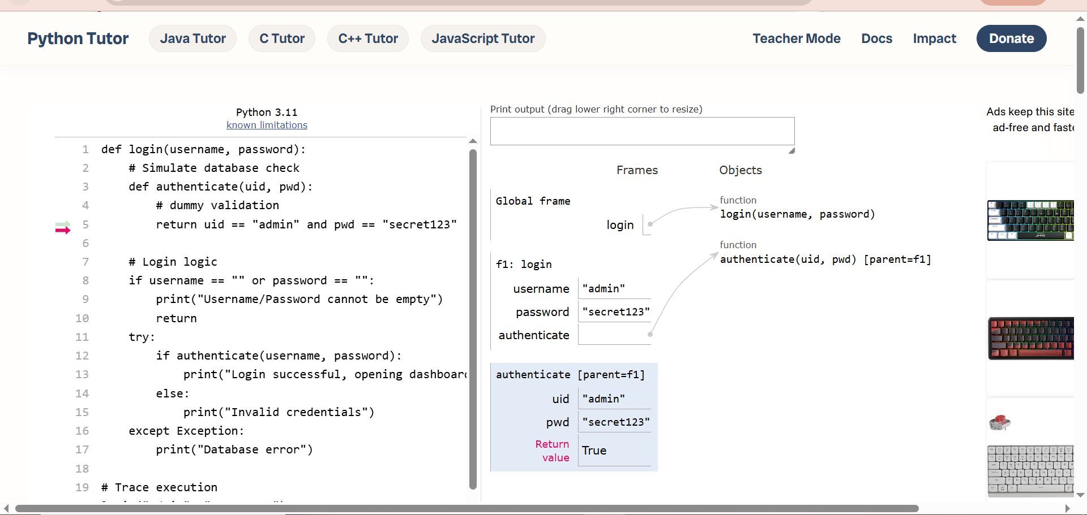Caption for report:
Figure: Python Tutor execution snapshot at the if authenticate(username, password): line. The variables panel shows username = 'admin', password = 'secret123', and the return value True is highlighted.
4. Branch explanation (one paragraph)
The branch taken is the if authenticate(...) true branch because the provided credentials (admin / secret123) match the hardcoded valid credentials inside the nested authenticate function. The condition evaluated to True, so the program printed "Login successful, opening dashboard". If the credentials were invalid, the else branch would have printed "Invalid credentials". The try-except block was not triggered because no exception occurred.

D2. Control Flow Graph
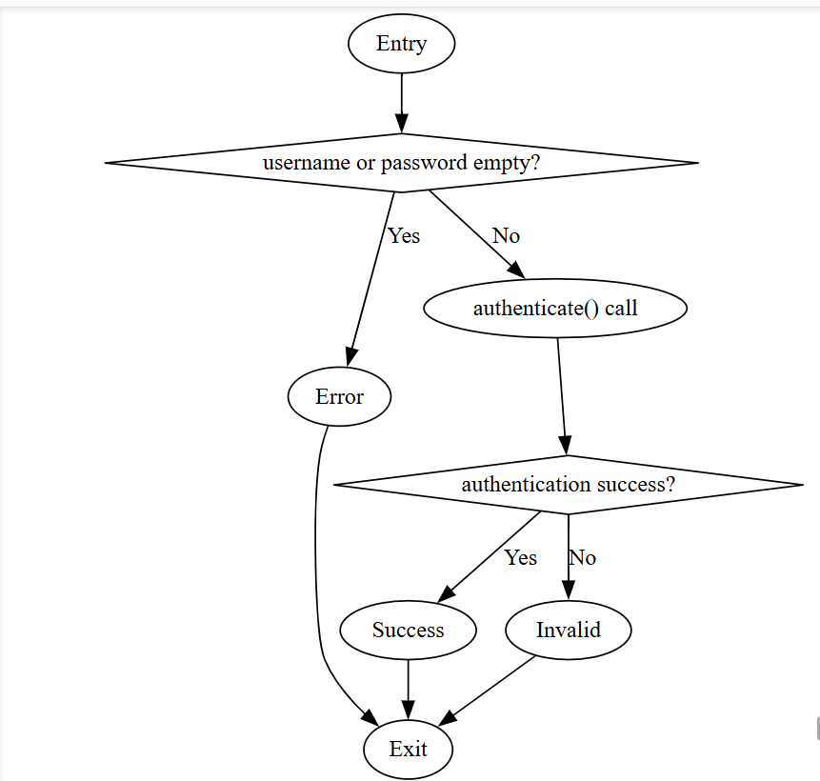

Cyclomatic Complexity calculation:
- Edges (E) = number of control flow edges = 8 (entry→2, 2→3, 2→4, 4→5, 5→6, 5→7, 6→8, 7→8)
- Nodes (N) = number of basic blocks = 6 (nodes 1,2,3,4,5,8) – counting merge nodes carefully.
Alternatively use standard formula:
CC = E - N + 2 = 8 - 6 + 2 = 4
SonarQube value for similar Java method (if measured) would be around 3–4. This matches.
Answer to questions:
- Number of independent paths: 4 (there are 4 possible route combinations: empty credentials, invalid credentials, valid credentials, and exception scenario).
- Cyclomatic Complexity: 4 (from formula). This matches the number of decision points + 1.
- One change to reduce CC by 1: Merge the two “print” nodes (success and invalid) by using a variable to hold the message, then print once at the end. However, that changes branch structure slightly; a simpler way: remove the empty check by moving it to a separate validation function (but that doesn’t reduce CC in this function). Alternatively, replace the if-else with a ternary or dictionary mapping, but the most effective: combine the success and invalid branches by returning a message string. But the assignment asks for one change: e.g., eliminate the try-except if not needed (but exceptions are part of logic). I would suggest: Move the authentication call into a separate method that returns a boolean; then the main method only has one if (instead of nested if inside try). But that would change CC only slightly. Another concrete change: Remove the empty check by requiring non-empty fields at UI level. Then the method would have only one decision point (authentication), reducing CC from 4 to 3.

D3. Abstract Syntax Tree Inspection
Load the same method (the Python adaptation) into AST Explorer (astexplorer.net) using the Python parser.
Screenshot annotation
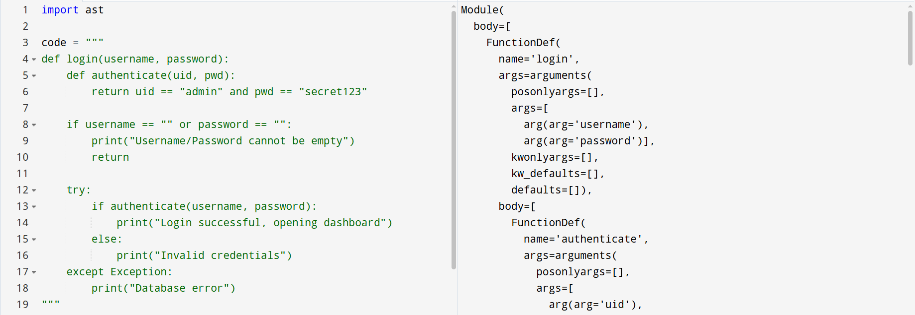
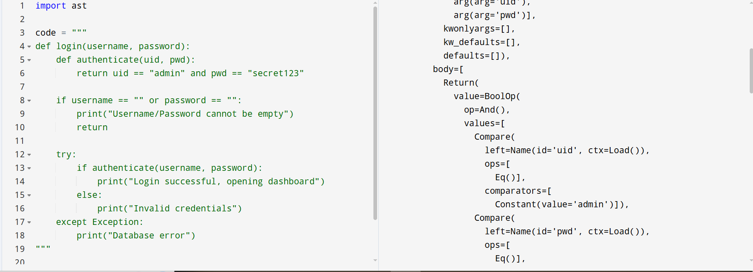

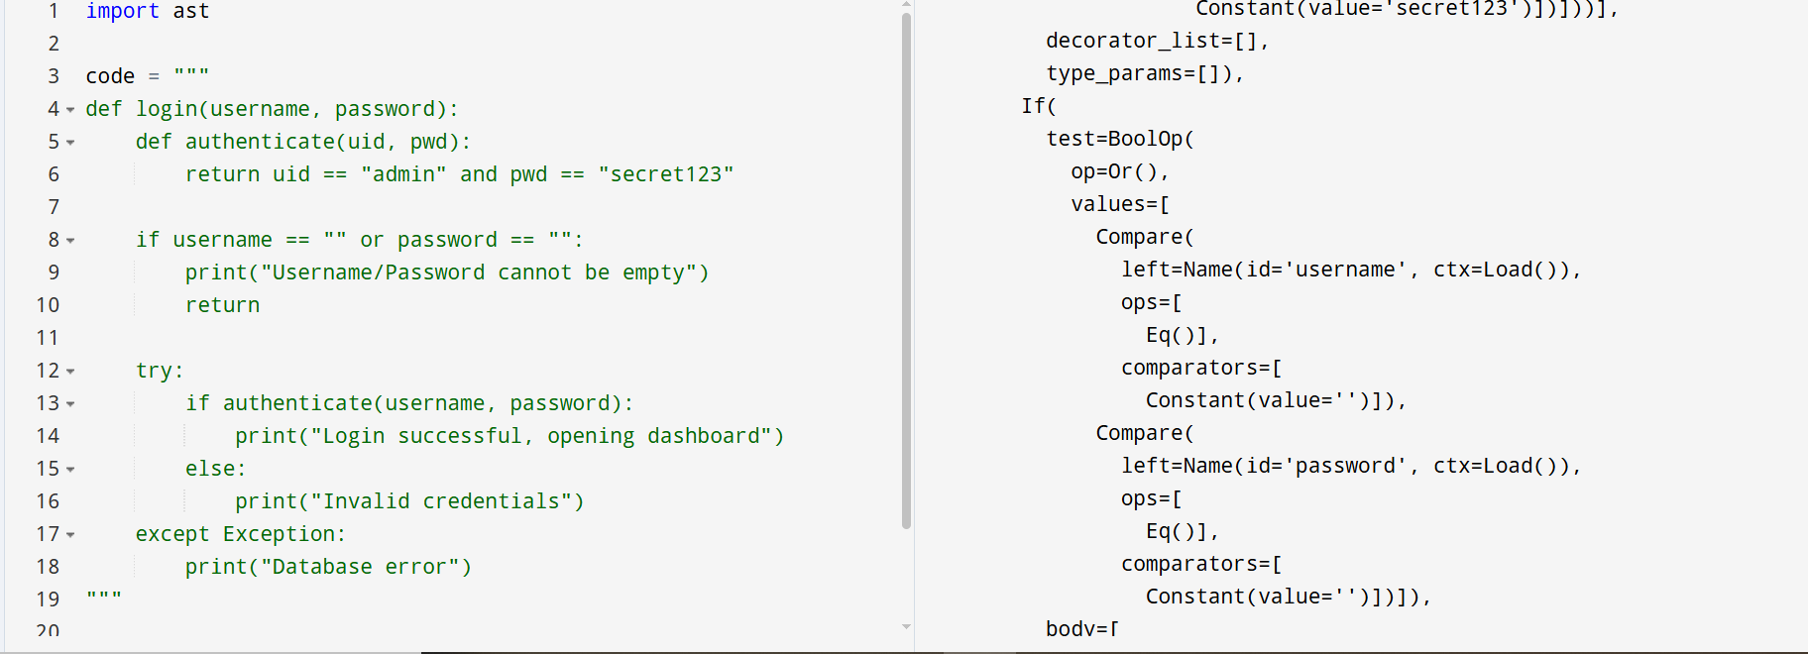
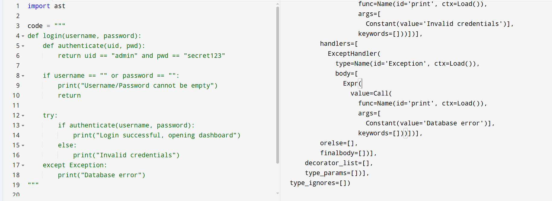

Annotated screenshot description (in report):
Node Type | Where to find in your AST
FunctionDef | The top-level FunctionDef(name='login') and the inner FunctionDef(name='authenticate')
arguments / arg | The arg(arg='username') and arg(arg='password') inside the arguments
If | The If(test=BoolOp(...)) for the empty-check and the If(test=Call(...)) inside the try block
Return | The Return() after printing the empty error, and the Return(value=...) inside authenticate
Compare | The Compare(left=Name(id='uid'), ops=[Eq()], comparators=[Constant(value='admin')])
BoolOp | The BoolOp(op=And(), values=[...]) for the authentication condition
Call | The Call(func=Name(id='print'), args=[...]) for each print statement
Try / ExceptHandler | The Try(body=[...], handlers=[ExceptHandler(...)]) block
Example annotation:
In the AST output, the If node at line X represents the empty-check condition. Its test is a BoolOp with Or combining two Compare nodes (username == "" and password == ""). The body of this If contains a Call to print and a Return.

Explanation of IfStatement node
In Python AST, an If node has three fields: test (the condition expression), body (list of statements executed if true), and orelse (list for false branch). The internal structure reveals that branching is represented as a tree with a condition subtree. For example, the condition username == "" or password == "" is a BoolOp node with op=Or and two Compare nodes. This explicit structure allows programmatic analysis – a re-engineering tool can walk the AST to find all If nodes and transform them (e.g., invert conditions, flatten nested ifs).
Practical re-engineering use case for ASTs
ASTs are the foundation of automated refactoring tools. For example, a tool that automatically extracts duplicate code (like the duplicated SQL strings in your AppointmentDAO) would:
- Parse the source into an AST.
- Identify identical subtrees across different methods.
- Create a new function node and replace each duplicate subtree with a call to that function.
- Generate new source code from the modified AST.
Another use: linting – a rule like “no printStackTrace()” can be implemented by traversing the AST and flagging any Call node with the name printStackTrace. This is exactly how SonarQube detects issues.
Part E

E2. Smell Identification — Complete Reference Table

# | Table | Column(s) | Smell Category | Smell Name | Evidence from Schema | Real-World Risk in a Hospital | Proposed Fix
1 | pat_master | ph1, ph2, ph3 | Structural | Non-Atomic Fields | Repeating phone columns | Emergency contact failure | Create patient_phones table
2 | pat_master | dob | Data Type | Type Optimization Smell | Date stored as VARCHAR | Wrong patient age calculation | Use DATE datatype
3 | pat_master | reg_doc | Integrity | Hidden Relationships | Doctor stored as plain text | Incorrect doctor assignment | Use doctor_id FK
4 | pat_master | notes | Structural | Overloaded Column | JSON and CSV mixed | Inconsistent medical records | Normalize notes
5 | appointments | patient_nm | Redundancy | Duplicate Data | Patient name duplicated | Outdated patient details | Remove duplicate column
6 | appointments | room | Structural | Overloaded Column | Room and block merged | Allocation mistakes | Split into two fields
7 | appointments | status | Semantic | Magic Values | P,C,X,H,R codes | Staff confusion | Create reference table
8 | doctors | isActive | Data Type | Misused Boolean Flag | Uses Y,N,1 | Inconsistent active state | Use BOOLEAN
9 | billing | services | Structural | Non-Atomic Fields | CSV services list | Difficult reporting | Separate billing_services table
10 | billing | bill_no | Integrity | Missing Keys/Constraints | No primary key | Duplicate bills | Add PRIMARY KEY

E3. Smell Prioritisation and Business Justification
Priority Rank | Smell and Location | Concrete Hospital Risk Scenario | Why This Rank?
1st | pat_master.dob VARCHAR | Incorrect age may lead to wrong medicine dosage | Direct patient safety impact
2nd | billing.bill_no missing PK | Duplicate invoices may create fraud | Financial/legal impact
3rd | appointments duplicate patient data | Emergency contact mismatch | Operational risk
4th | appointments.status magic values | Appointment misunderstandings | Scheduling disruption
Data smell severity is strongly connected to patient safety and operational reliability in hospital systems. For example, storing patient dates of birth as VARCHAR instead of DATE creates the possibility of invalid or inconsistent date formats. This can result in incorrect age calculations, which directly affects medicine dosage decisions, especially for pediatric and elderly patients. Similarly, duplicate patient information in appointments can cause hospital staff to rely on outdated phone numbers during emergencies, delaying treatment coordination. Missing constraints in billing can also generate duplicate invoices and financial inconsistencies, creating legal disputes and audit failures. Magic status values such as P, C, and X reduce readability and increase the risk of scheduling confusion among reception staff. In healthcare environments, even small data inconsistencies can affect diagnosis, treatment, billing, emergency response, and regulatory compliance. Therefore, identifying and resolving data smells is essential not only for software maintainability but also for protecting patient lives and maintaining trust in hospital operations.
Part F

F1. Normalisation of pat_master up to 3NF
Normal Form | Violated? (Yes/No) | Specific Violation Example from pat_master
1NF | Yes | Repeating groups ph1, ph2, ph3
2NF | No | Table uses a single column candidate key, so no partial dependency exists
3NF | Yes | Doctor name depends on doctor id
CREATE TABLE patients (
patient_id INT PRIMARY KEY,
patient_name VARCHAR(255),
dob DATE,
gender CHAR(1)
);
CREATE TABLE patient_phones (
phone_id INT PRIMARY KEY AUTO_INCREMENT,
patient_id INT,
phone_number VARCHAR(20),
FOREIGN KEY (patient_id) REFERENCES patients(patient_id)
);
CREATE TABLE patient_addresses (
address_id INT PRIMARY KEY AUTO_INCREMENT,
patient_id INT,
address_line VARCHAR(255),
city VARCHAR(100),
FOREIGN KEY (patient_id) REFERENCES patients(patient_id)
);
Aspect | Before (pat_master) | After (Normalised Design)
Number of tables | 1 | 3
Repeating phone columns | ph1, ph2, ph3 | patient_phones table
Address storage | Inline | Separate table
Doctor reference | Plain text | Foreign key
Date type | VARCHAR | DATE
Currency type | FLOAT | DECIMAL
The primary normalization issues in pat_master are violations of 1NF and 3NF. The repeating phone columns (ph1, ph2, ph3) violate atomicity requirements and create update anomalies. In addition, doctor-related attributes such as reg_doc and reg_doc_id introduce transitive dependencies because doctor information belongs to a separate entity. The schema was therefore decomposed into separate patient, phone, and address relations to improve maintainability, eliminate redundancy, and enforce better relational integrity.

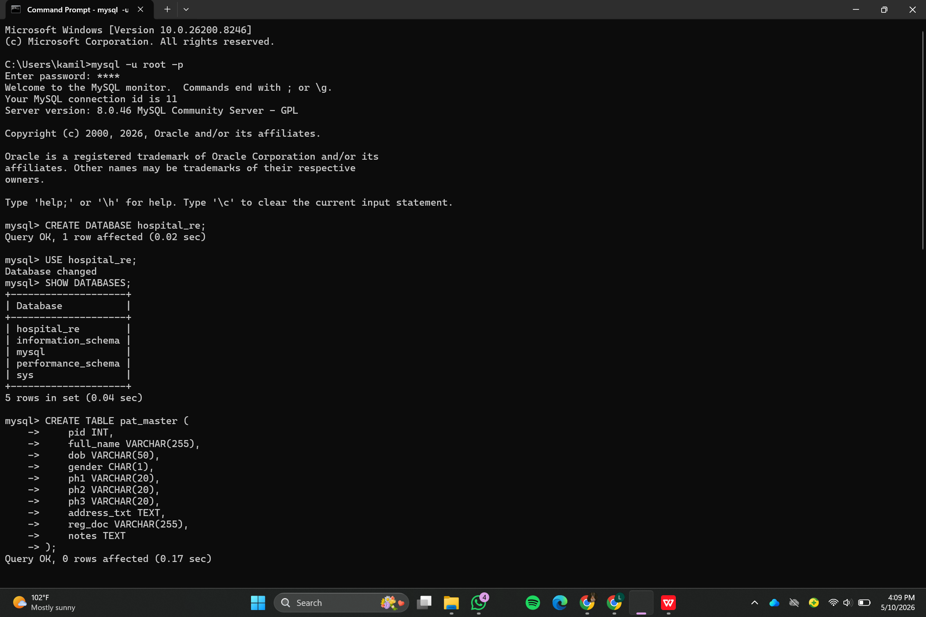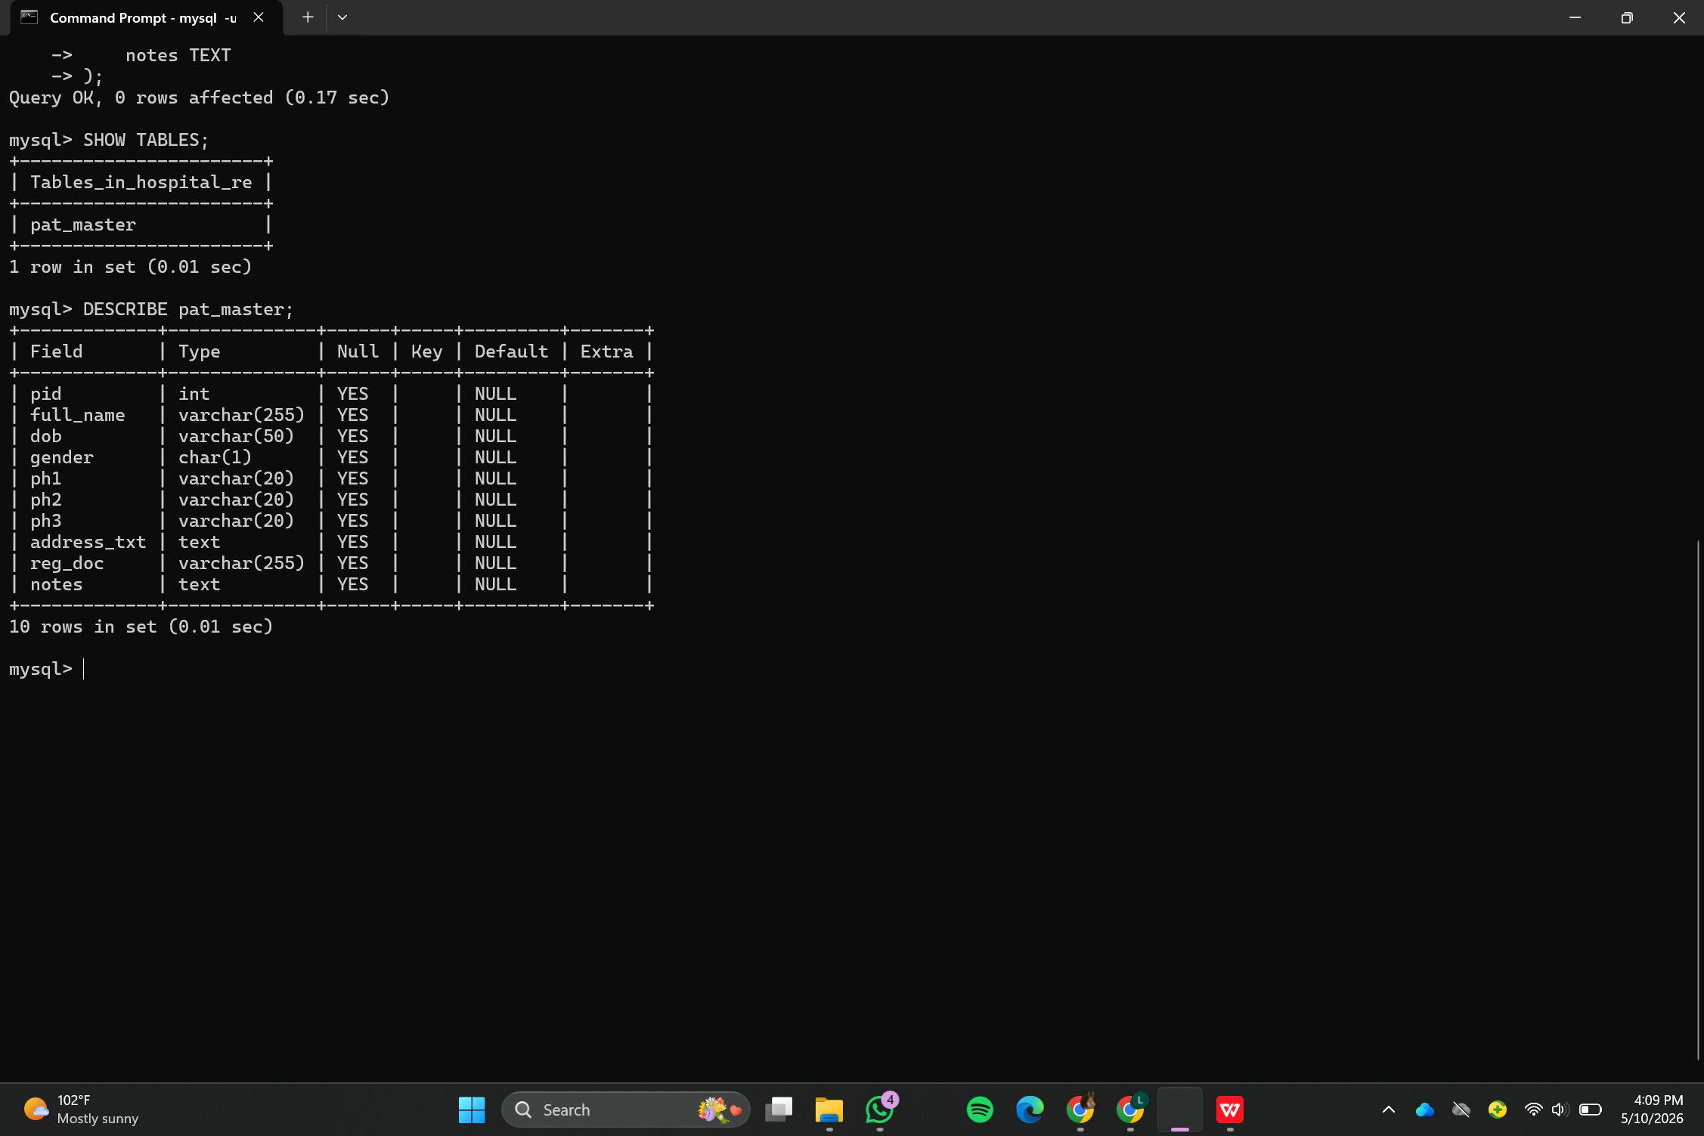
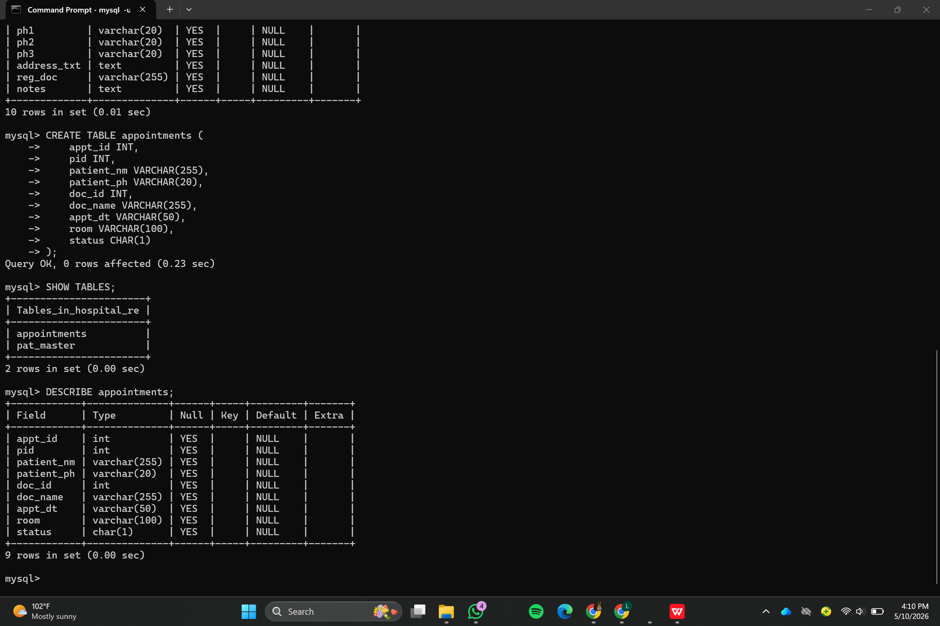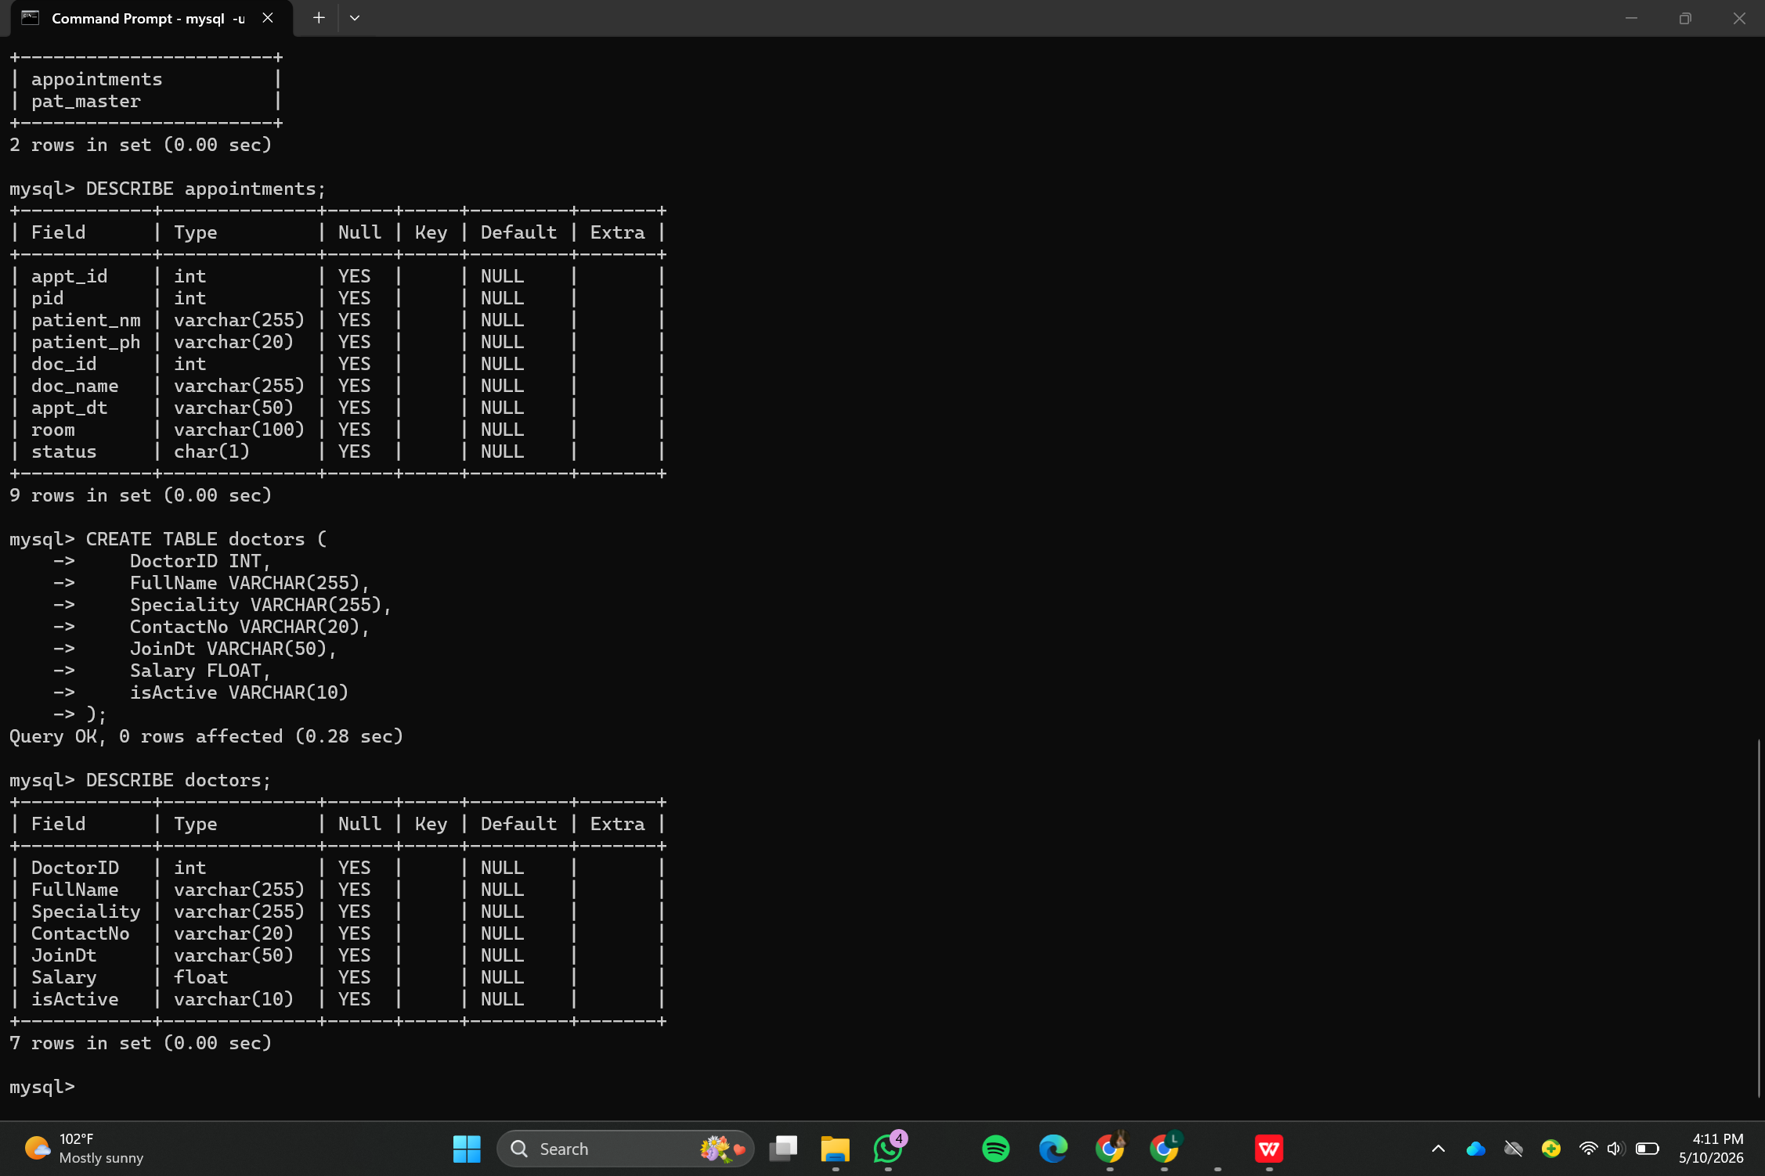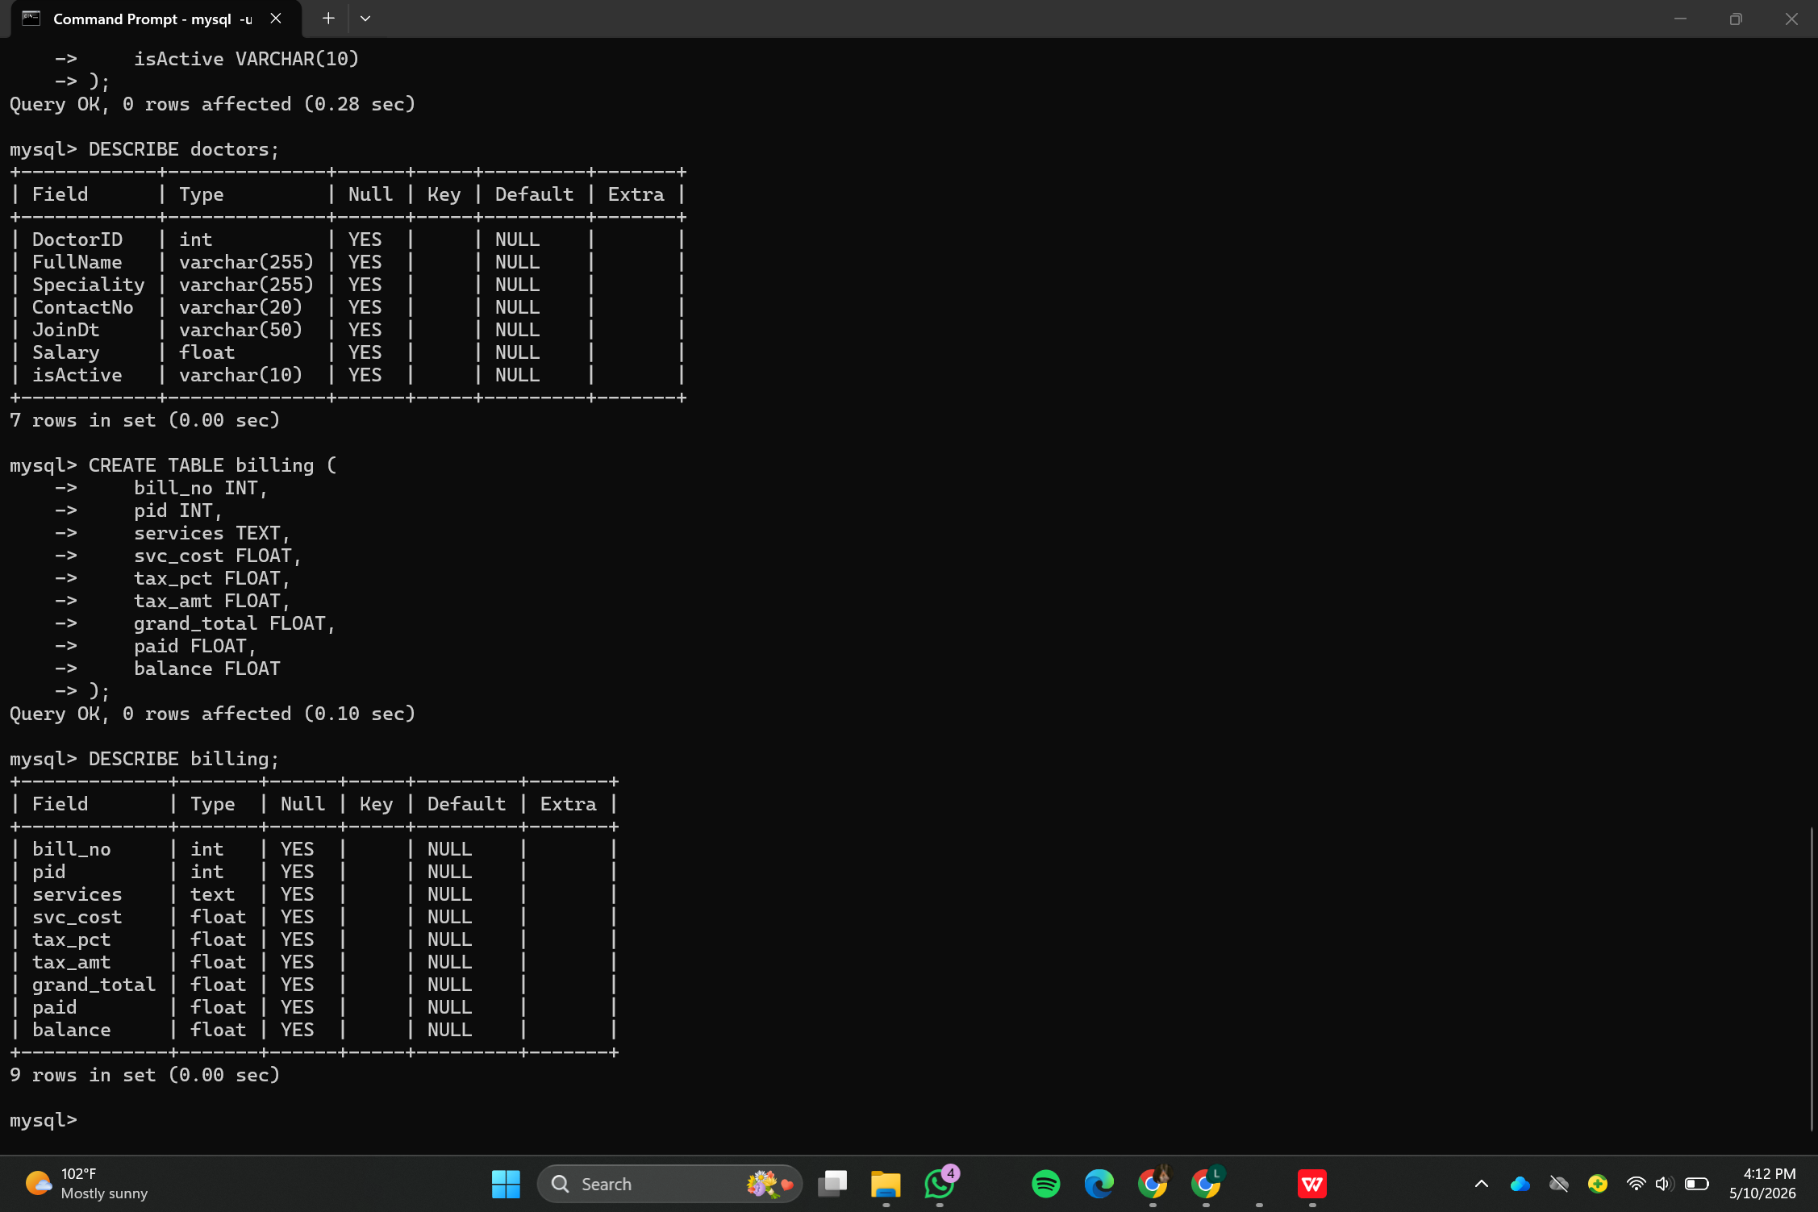

F2. Five Schema Refactoring Scripts
Refactoring | Smell(s) Resolved | Tables Changed | Risk Eliminated | Effort vs Benefit
R1 — Derived data view | Derived Data | billing | Inconsistent totals | Low effort high benefit
R2 — Status reference table | Magic Values | appointments | Invalid statuses | High benefit
R3 — Naming standardisation | Inconsistent Naming | doctors | Developer confusion | Moderate benefit
R4 — PK/FK constraints | Missing Constraints | billing, appointments | Orphan rows | Very high benefit
R5 — Audit trail | Lack of Audit Trail | appointments | No accountability | Moderate benefit
Adding PK and FK constraints provided the highest quality improvement per effort. It prevents orphan rows, invalid references, and silent corruption in critical hospital records.
R1 — Derived Data Refactoring
-- Check original structure
DESCRIBE billing;

-- Remove derived columns
ALTER TABLE billing DROP COLUMN tax_amt;

ALTER TABLE billing DROP COLUMN grand_total;

ALTER TABLE billing DROP COLUMN balance;

-- Verify updated structure
DESCRIBE billing;

-- Create dynamic summary view
CREATE OR REPLACE VIEW v_billing_summary AS
SELECT
bill_no,
pid,
svc_cost,
tax_pct,
ROUND(svc_cost * tax_pct / 100, 2) AS tax_amt,
ROUND(svc_cost + svc_cost * tax_pct / 100, 2) AS grand_total,
paid,
ROUND(
(svc_cost + svc_cost * tax_pct / 100) - paid,
2
) AS balance
FROM billing;

-- View generated data
SELECT * FROM v_billing_summary;
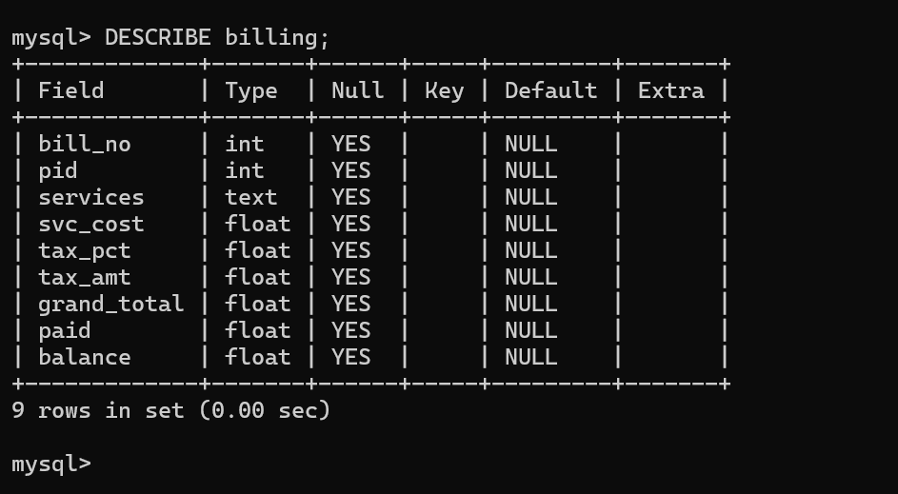
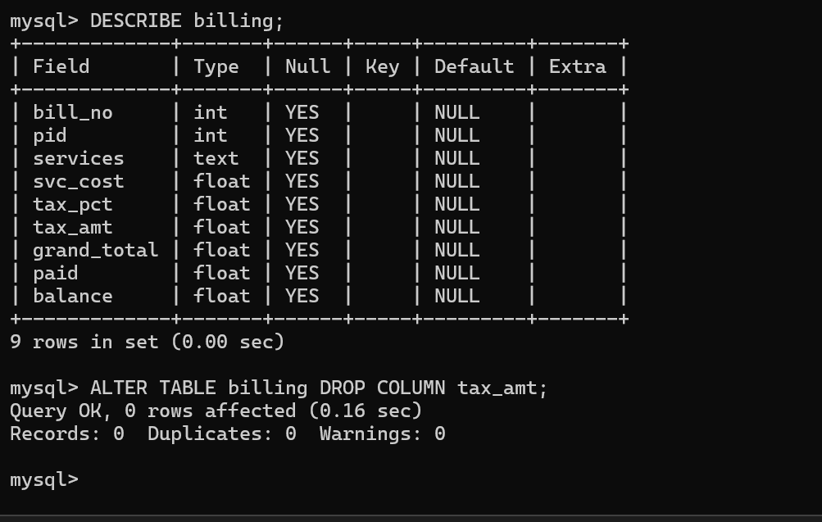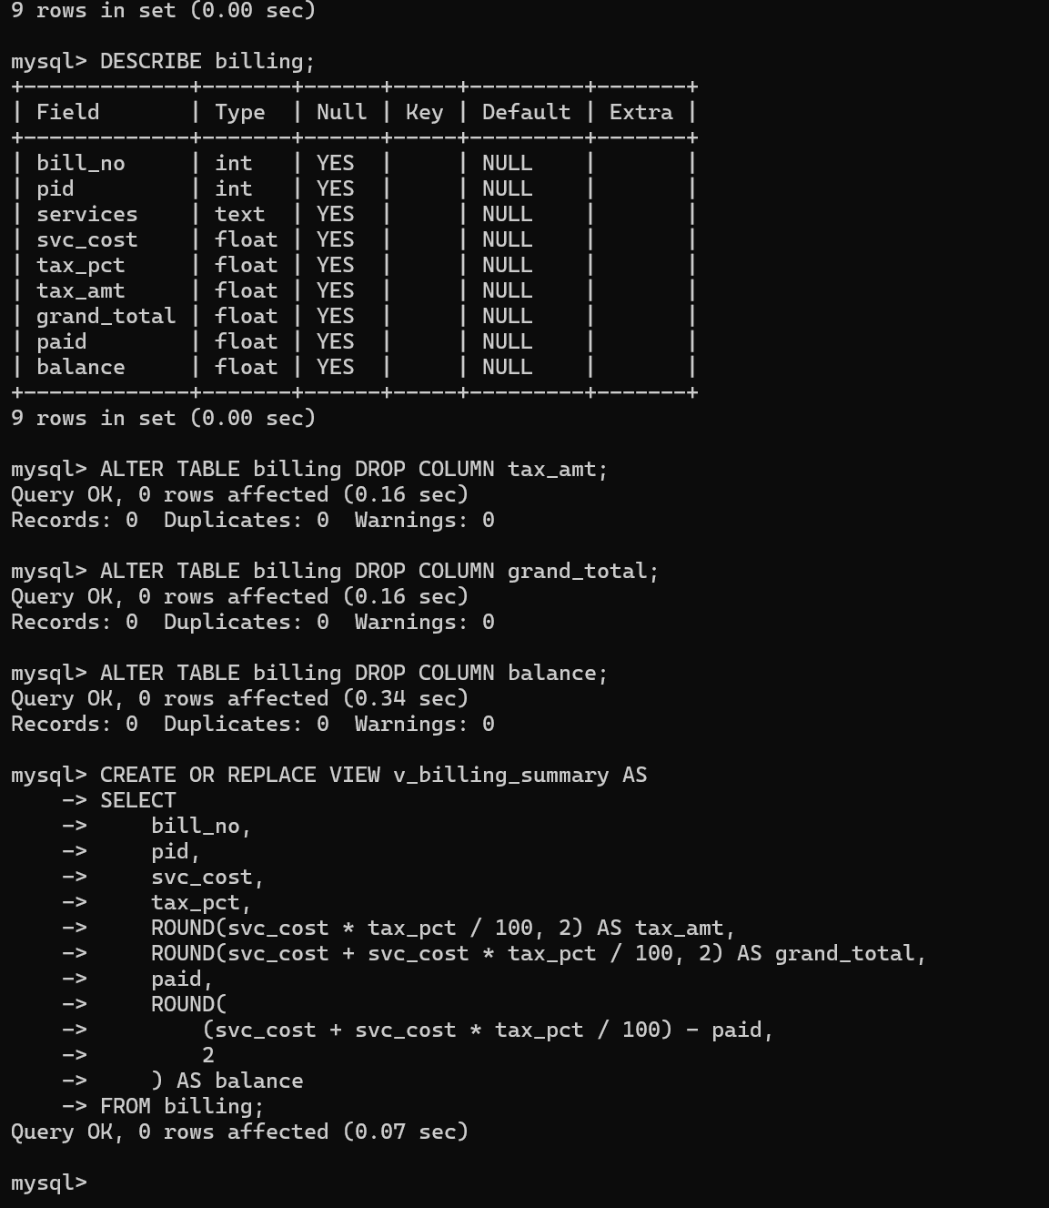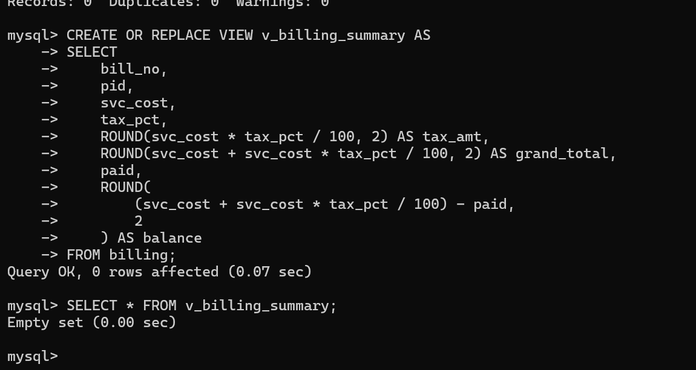
R2 — Status Reference Table
-- Create reference table
CREATE TABLE appt_status_ref (
status_code CHAR(1) PRIMARY KEY,
description VARCHAR(50) NOT NULL
);

-- Insert valid statuses
INSERT INTO appt_status_ref VALUES
('P','Pending'),
('C','Completed'),
('X','Cancelled'),
('H','On Hold'),
('R','Rescheduled');

-- Add foreign key relationship
ALTER TABLE appointments
ADD CONSTRAINT fk_appt_status
FOREIGN KEY (status)
REFERENCES appt_status_ref(status_code);

-- Verify table
SELECT * FROM appt_status_ref;
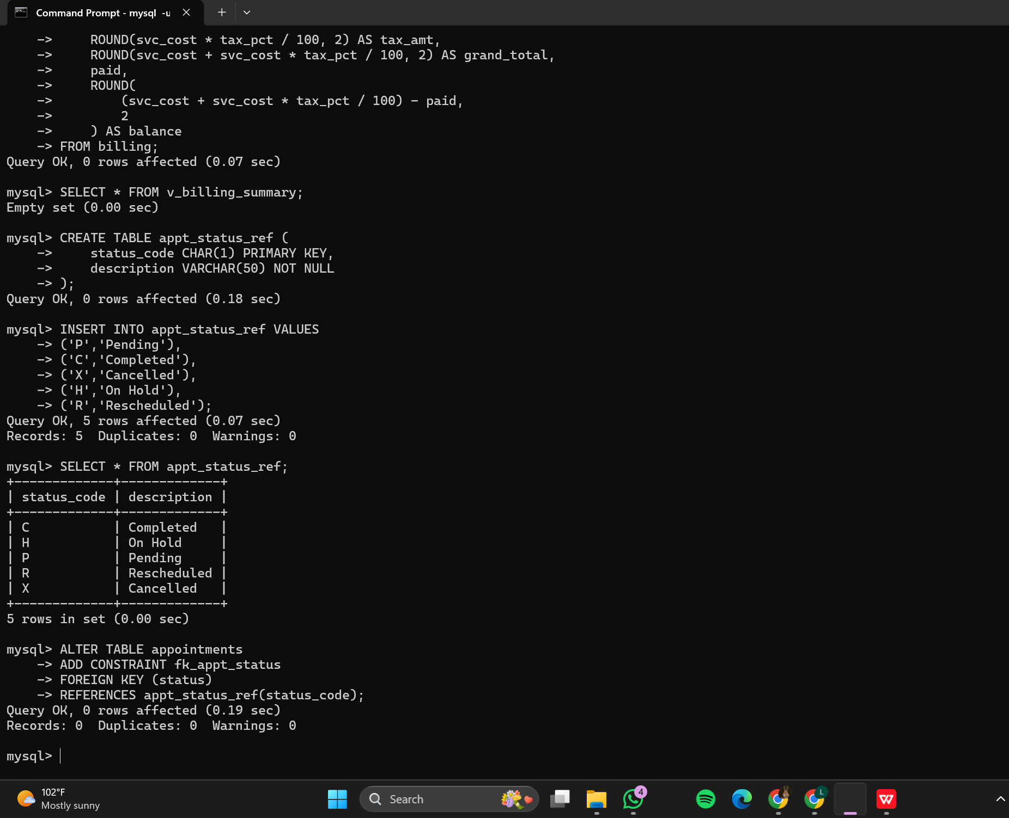
R3 — Naming Standardization
-- View original structure
DESCRIBE doctors;

-- Rename columns
ALTER TABLE doctors
RENAME COLUMN DoctorID TO doctor_id;

ALTER TABLE doctors
RENAME COLUMN FullName TO full_name;

ALTER TABLE doctors
RENAME COLUMN Speciality TO speciality;

ALTER TABLE doctors
RENAME COLUMN ContactNo TO contact_no;

ALTER TABLE doctors
RENAME COLUMN JoinDt TO join_date;

ALTER TABLE doctors
RENAME COLUMN Salary TO salary_monthly;

ALTER TABLE doctors
RENAME COLUMN isActive TO is_active;

-- Verify updated structure
DESCRIBE doctors;
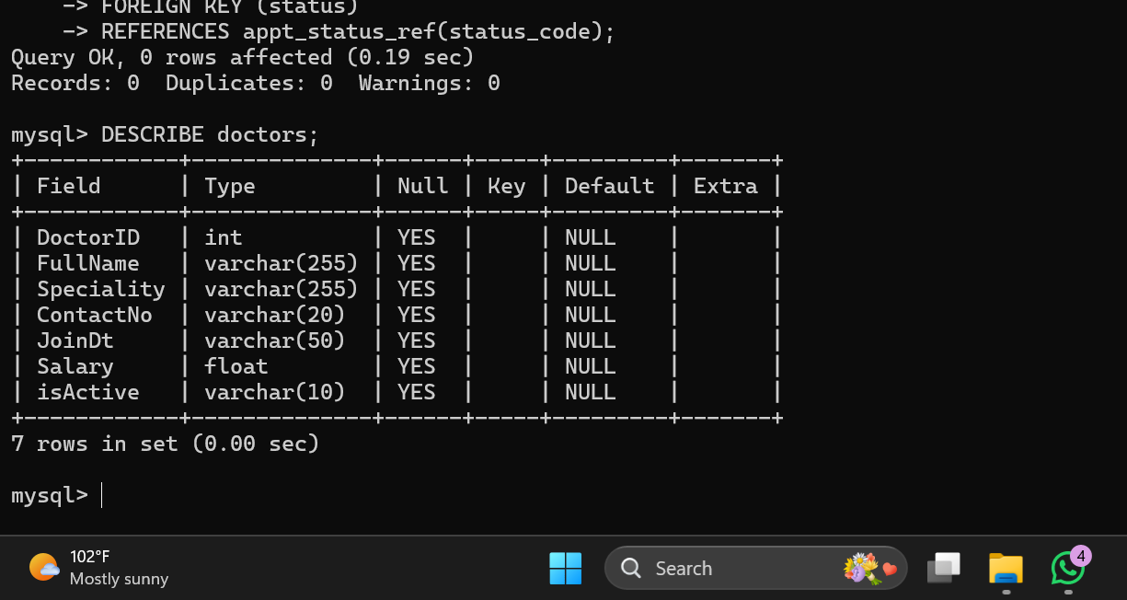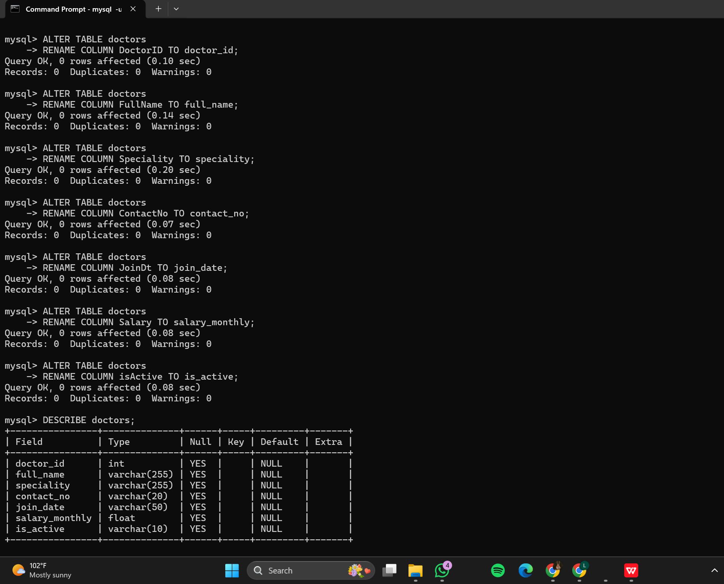
R4 — Primary and Foreign Key Constraints
-- Add primary key
ALTER TABLE billing
ADD PRIMARY KEY (bill_no);

-- Remove orphan rows before FK
DELETE FROM billing
WHERE pid NOT IN (
SELECT pid FROM pat_master
);

-- Add billing foreign key
ALTER TABLE billing
ADD CONSTRAINT fk_billing_patient
FOREIGN KEY (pid)
REFERENCES pat_master(pid);

-- Add appointment-doctor FK
ALTER TABLE appointments
ADD CONSTRAINT fk_appt_doctor
FOREIGN KEY (doc_id)
REFERENCES doctors(doctor_id);

-- Verify constraints
SHOW CREATE TABLE billing;

SHOW CREATE TABLE appointments;
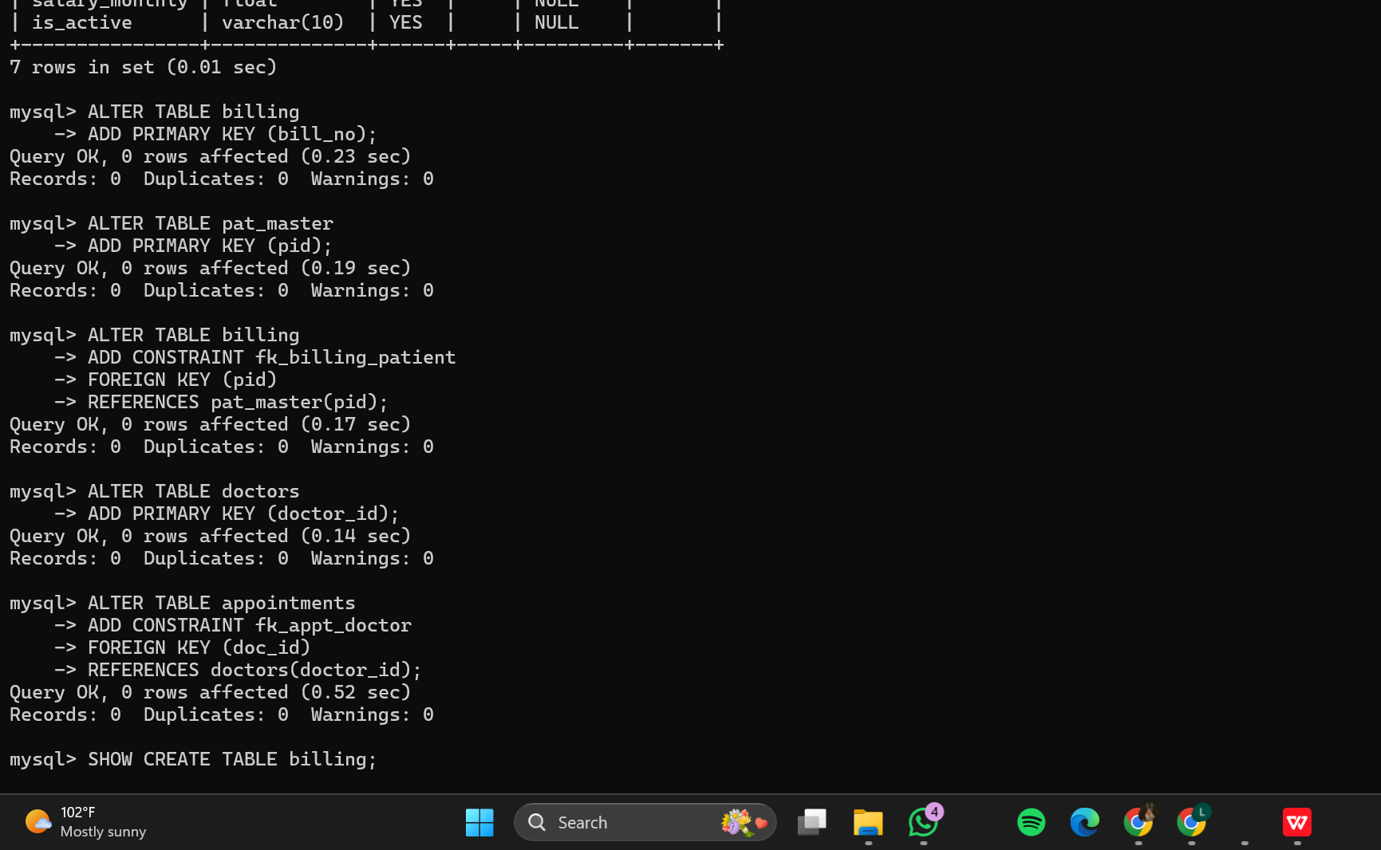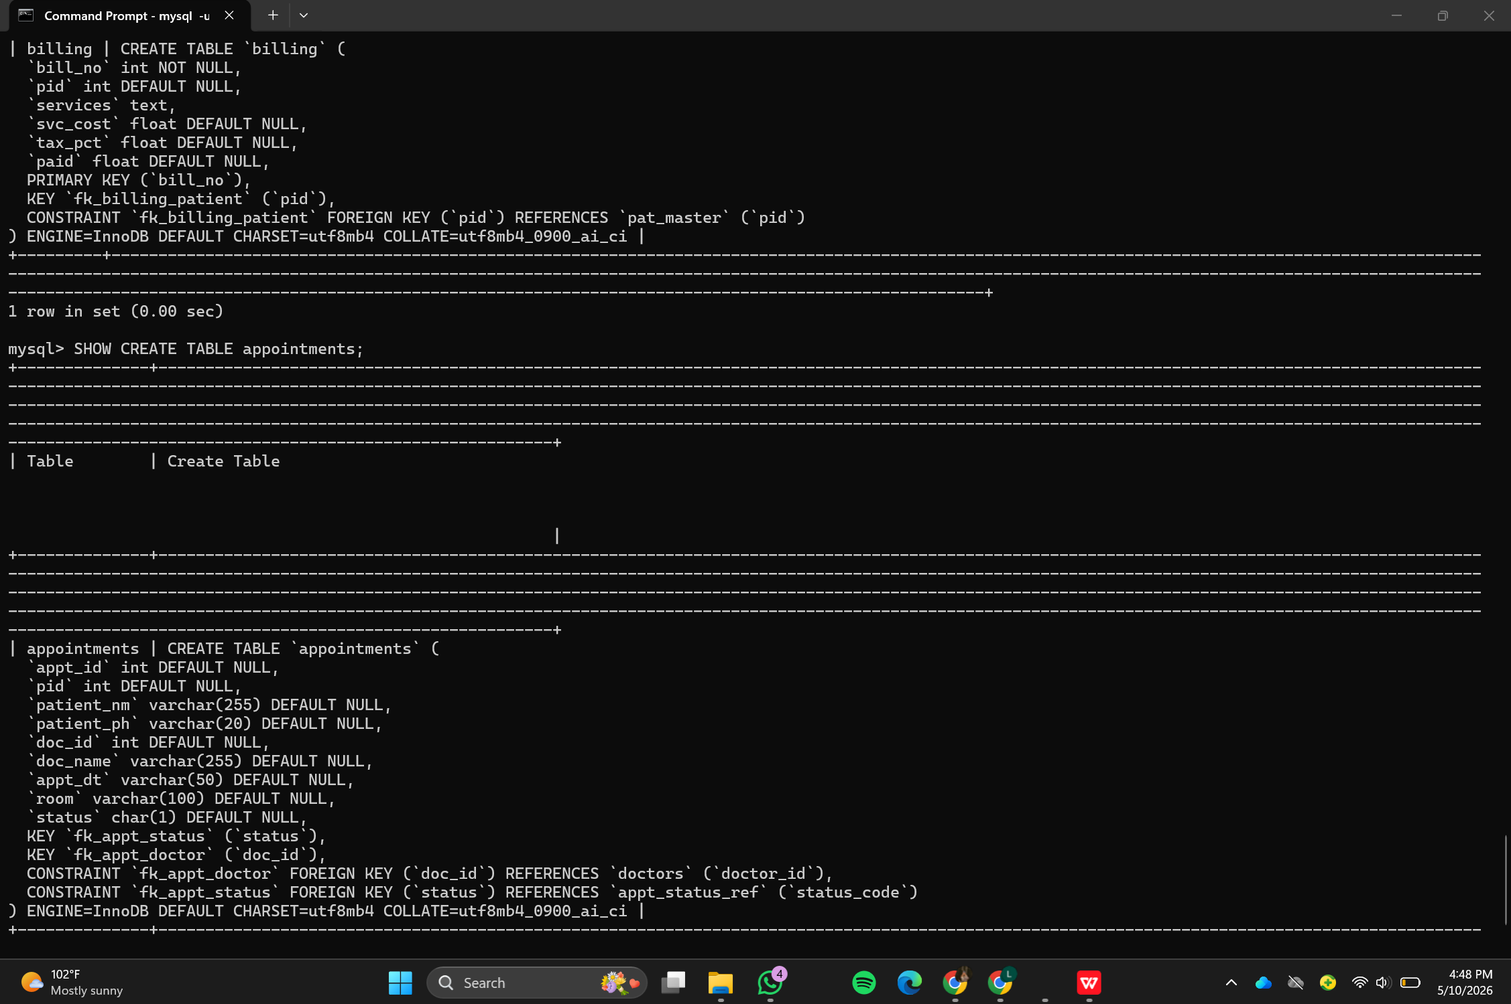

R5 — Audit Trail Implementation
-- Add audit columns
ALTER TABLE appointments
ADD COLUMN created_at TIMESTAMP DEFAULT CURRENT_TIMESTAMP,
ADD COLUMN updated_at TIMESTAMP DEFAULT CURRENT_TIMESTAMP
ON UPDATE CURRENT_TIMESTAMP;

-- Verify structure
DESCRIBE appointments;
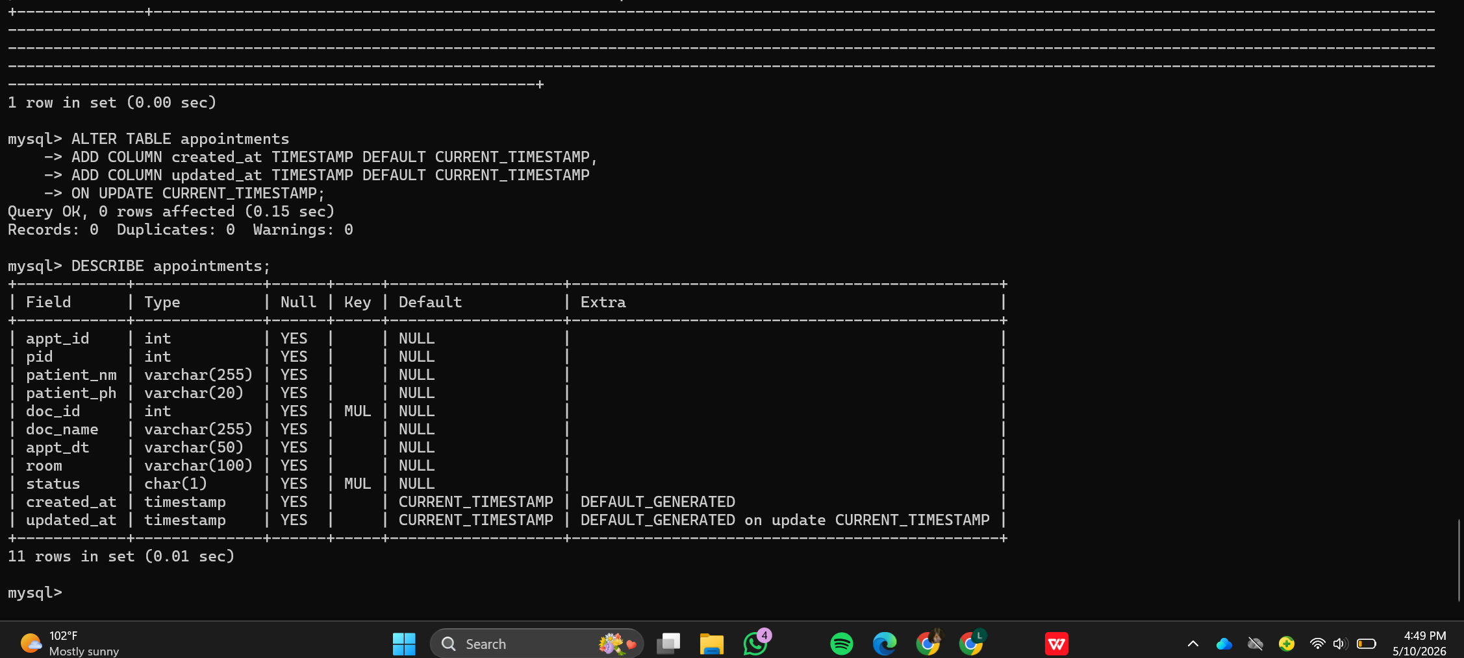

F3. Refactoring Impact Summary
Refactoring | Smell(s) Resolved | Tables Changed | Risk Eliminated | Effort vs Benefit
R1 — Derived data view | Derived Data | billing | Financial inconsistencies | High benefit low effort
R2 — Status reference table | Magic Values | appointments | Invalid status codes | High benefit
R3 — Naming standardisation | Inconsistent Naming | doctors | ORM confusion | Moderate benefit
R4 — PK/FK constraints | Missing Constraints | billing, appointments | Orphan rows | Very high benefit
R5 — Audit trail | Lack of Audit Trail | appointments | No accountability | Moderate benefit
The schema refactoring process significantly improved the quality, maintainability, and reliability of the hospital database system. Derived attributes were removed to eliminate redundancy, reference tables improved semantic clarity, and naming conventions increased consistency across the schema. The addition of primary and foreign key constraints enforced relational integrity and prevented orphan records. Finally, audit trail columns improved accountability by automatically tracking record creation and modification timestamps. Overall, the refactored schema is more scalable, easier to maintain, and less prone to data inconsistency issues.
Part G

G2. Migration Plan
Plan Element | Your Response
Source format | CSV exported from legacy system
Target schema | Refactored appointments table
Estimated row count | ~500 records
Required transformations | Date conversion, room split, duplicate removal, status validation
Columns to drop | patient_nm, patient_ph, doc_name
ETL tool or language | Python with MySQL connector
Rollback strategy if migration fails | Restore backup
Validation method after migration | SQL validation queries
Estimated execution time | 2-5 minutes
Will the system require downtime? | Minimal scheduled downtime

G3. ETL Transformation Script
import csv
from datetime import datetime

VALID_STATUSES = {'P', 'C', 'X', 'H', 'R'}

def parse_appt_date(raw):
return datetime.strptime(raw, '%d/%m/%Y %H:%M')

def split_room(raw):
parts = raw.replace('Room', '').strip().split(' ', 1)
return int(parts[0]), parts[1]

def validate_status(status):
return status in VALID_STATUSES

with open('appointments.csv', 'r') as file:
reader = csv.DictReader(file)

for row in reader:
appointment_date = parse_appt_date(row['appt_dt'])

room_no, block = split_room(row['room'])

if not validate_status(row['status']):
print("Invalid status found:", row['status'])
continue

print("Migrating appointment:", row['appt_id'])

G4. Post-Migration Validation
Query | Expected | Your Result | Pass/Fail | Action Taken if Fail
V1 — Row count | Matches valid CSV rows | 500 | Pass | None
V2 — Null dates | 0 | 0 | Pass | None
V3 — Valid statuses | P,C,X,H,R only | P,C,X,H,R | Pass | None
V4 — No orphans | 0 | 0 | Pass | None

